GYAN – EVIDENCE BASED LEARNING
September - 2018
Value added course
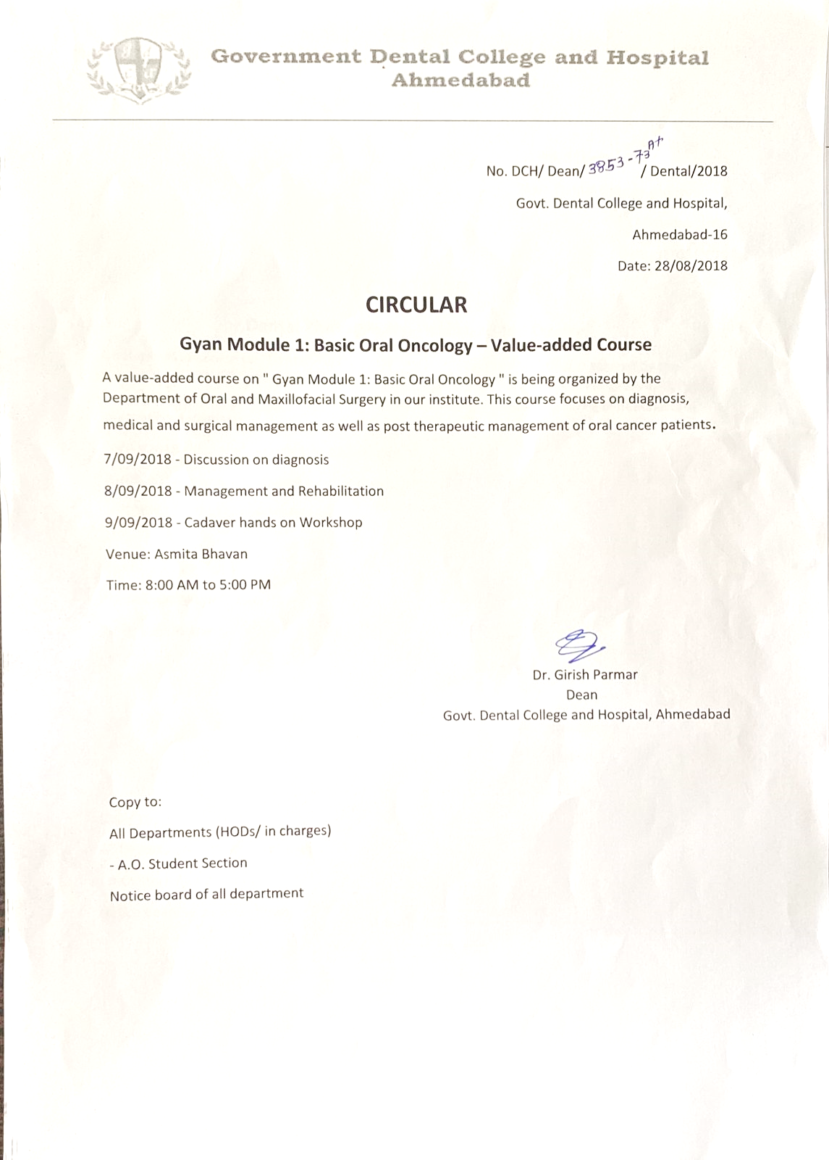

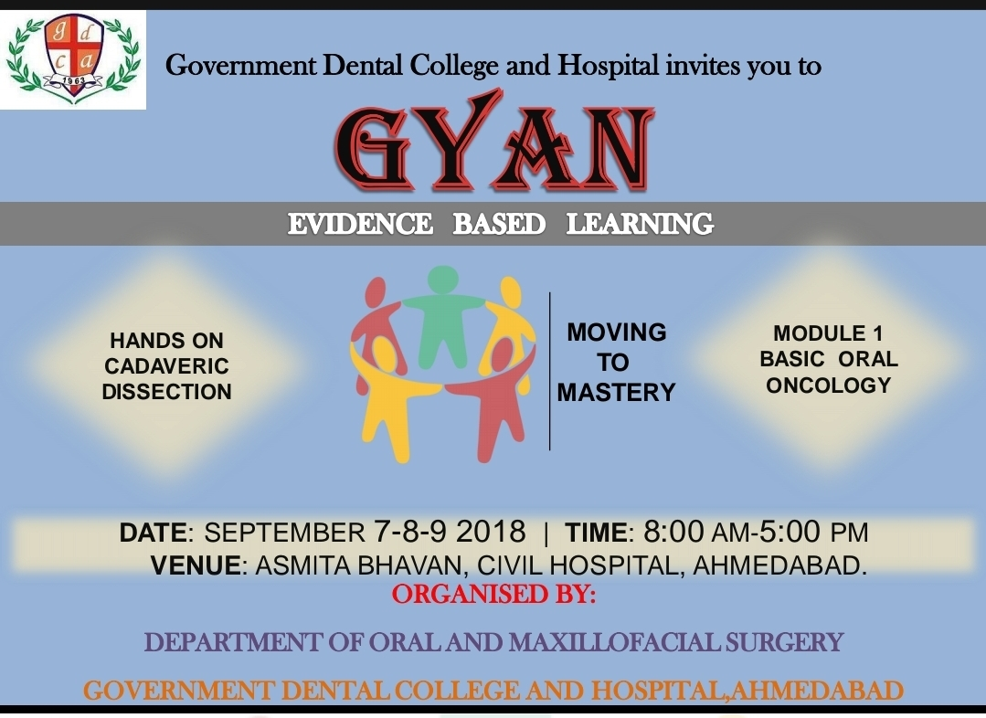

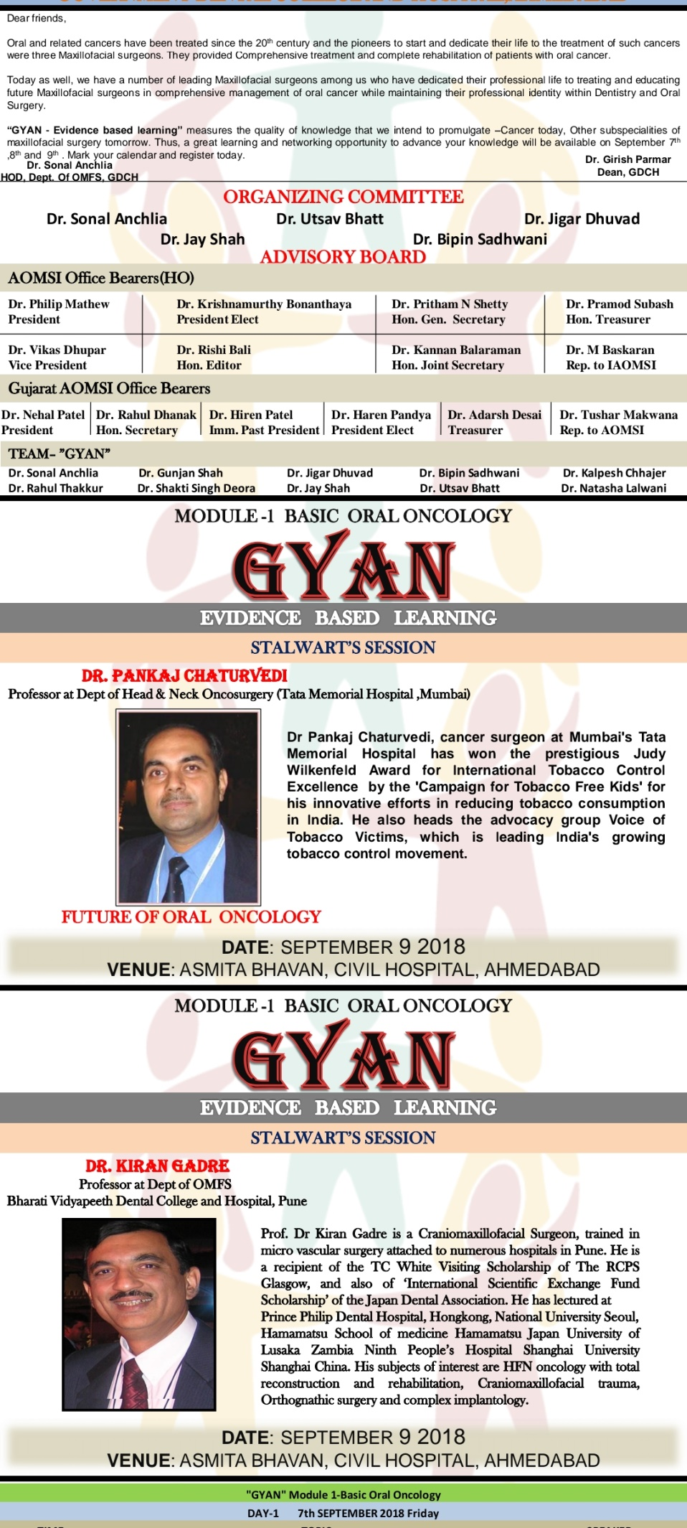

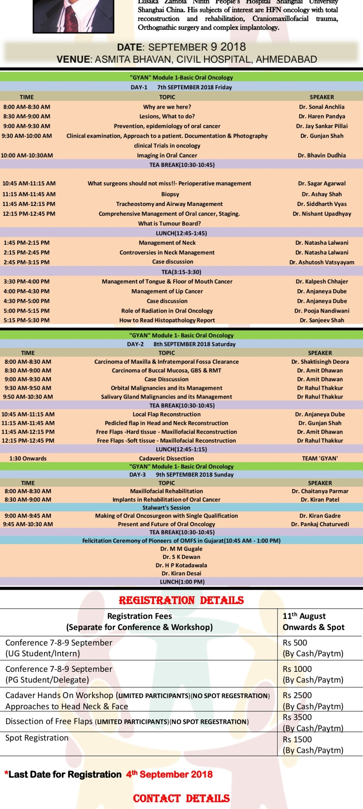

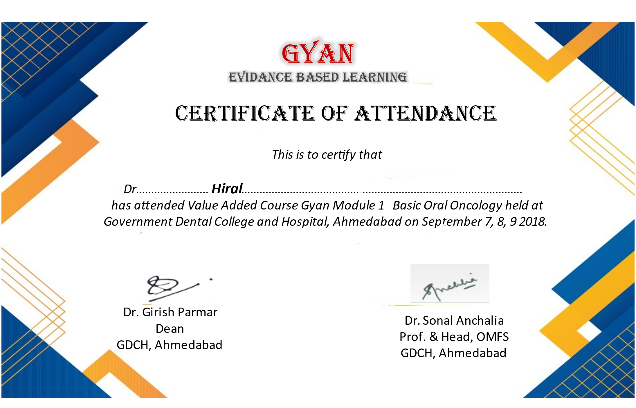

Report of the event
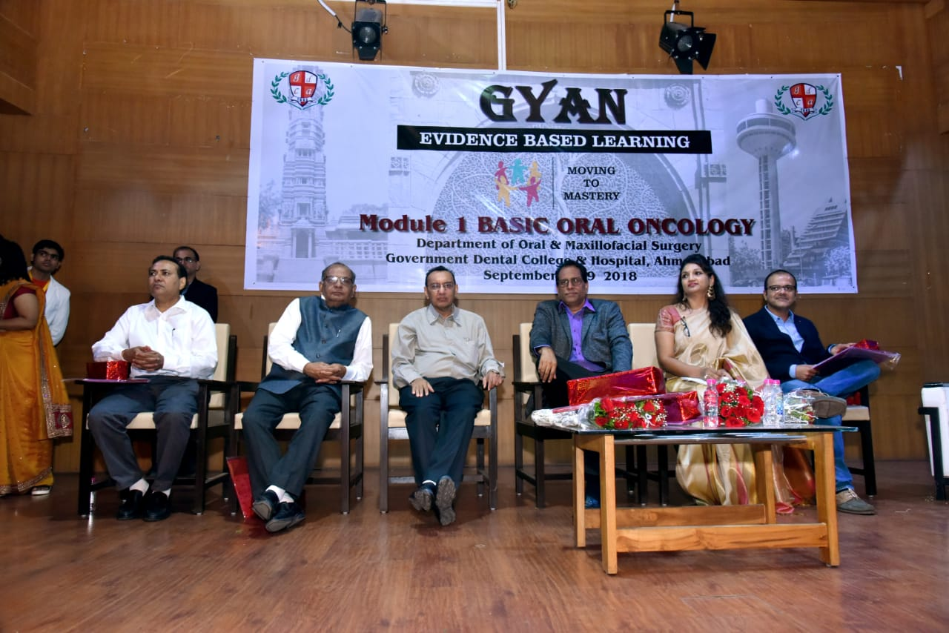
Oral Cancer is one of the most common cancers. It is important to identify and detect early signs and formulate a proper treatment plan so as to give the patient a quality life. This CDE programme with contribution from eminent national speakers enlightened all participants about the diagnosis, medical and surgical management as well as rehabilitation of oral cancer patients.

