Dental Photography – Value added course

4th – 6th September 2018

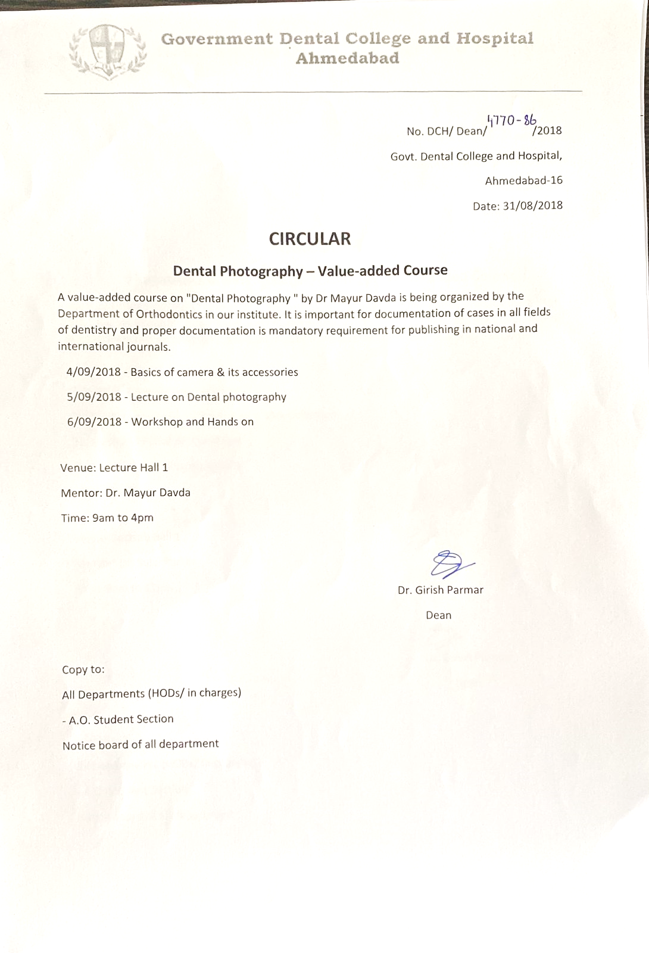

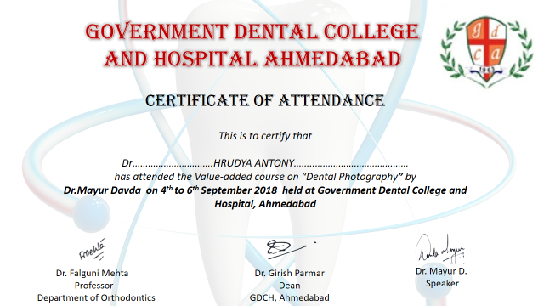

REPORT OF THE EVENT

Dental photography is an essential part of the dental curriculum. It is important for documentation of cases in all fields of dentistry, as proper documentation is mandatory requirement for publishing in national and international journals. This value-added course conducted by Dr. Mayur Dawda has enlightened all participants with knowledge about dental photography.
Dr. Mayur Dawda is one of the eminent instructor and guide in India for Dental photography, has conducted several sessions and had enlightened several students with their knowledge.
This course was attended by 37 students and 13 staff members

