Biostatistics & Research Methodology
January 2021
Value added course

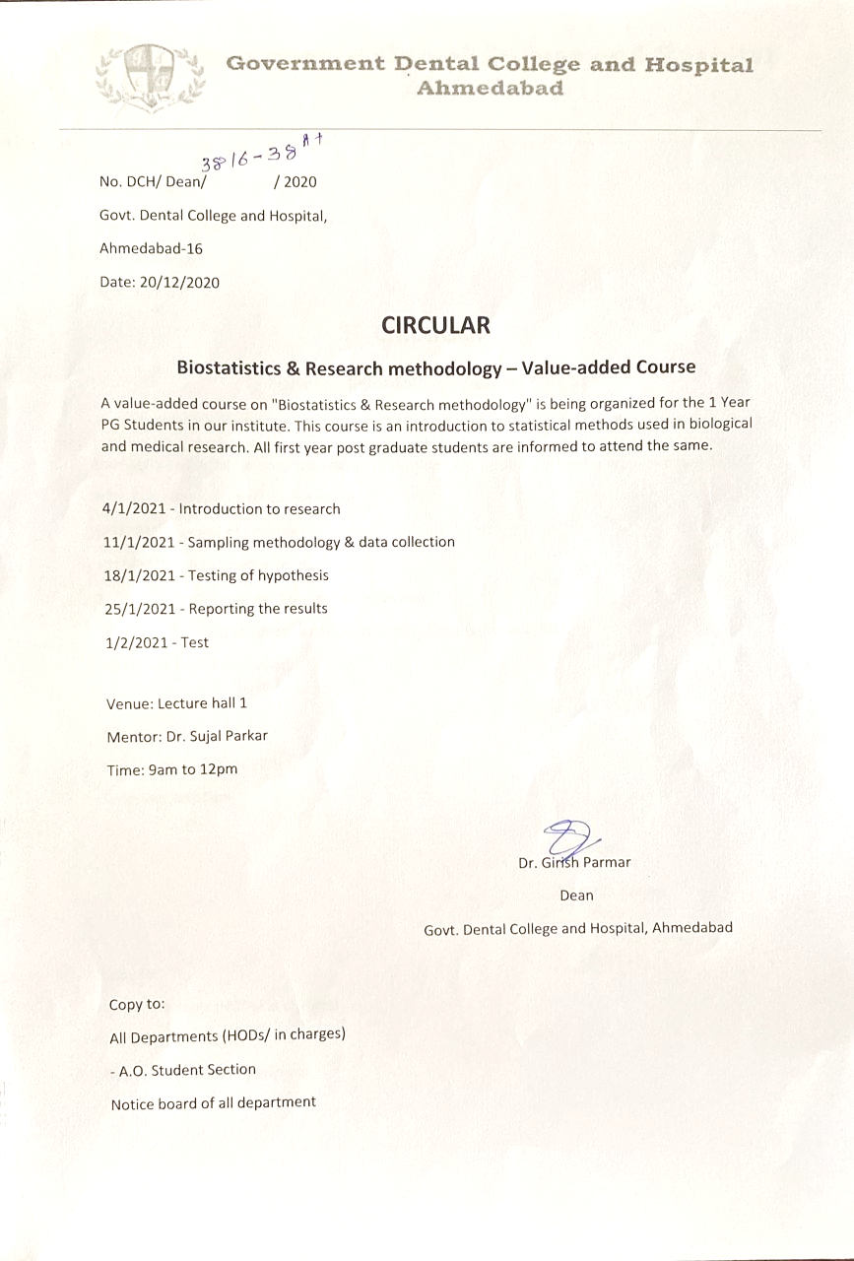

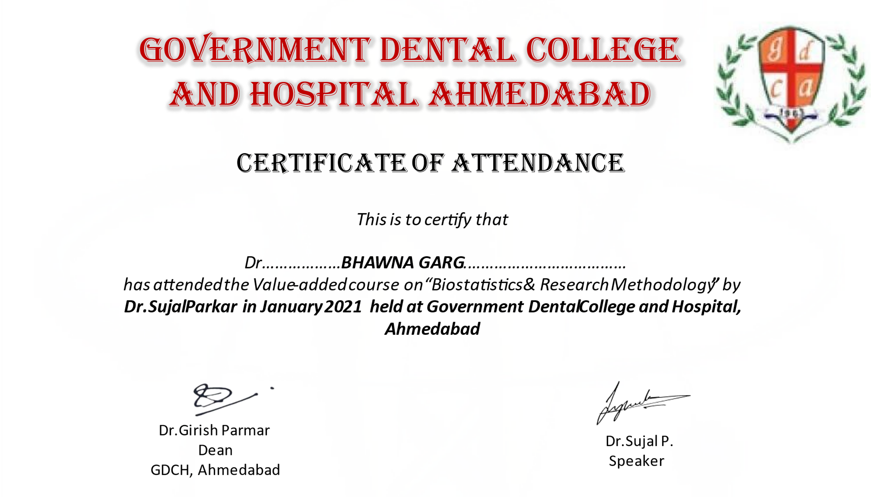

Report of the event

This course has given Sound conceptual understanding of various research methods, research instruments, tools and techniques essential prerequisite in conducting empirical research. For undergoing high quality research and writing good research papers, one requires to collect, interpret and logically document the information. The art of drawing coherent conclusions, supported by appropriate research tools and reference citation is vital for quality research work. This course has given this opportunity to the students to enhance the knowledge of biostatistics, their researching skills and understand the methodologies.

This course was attended by 35 students.
