Biostatistics & Research Methodology
January 2020
Value added course

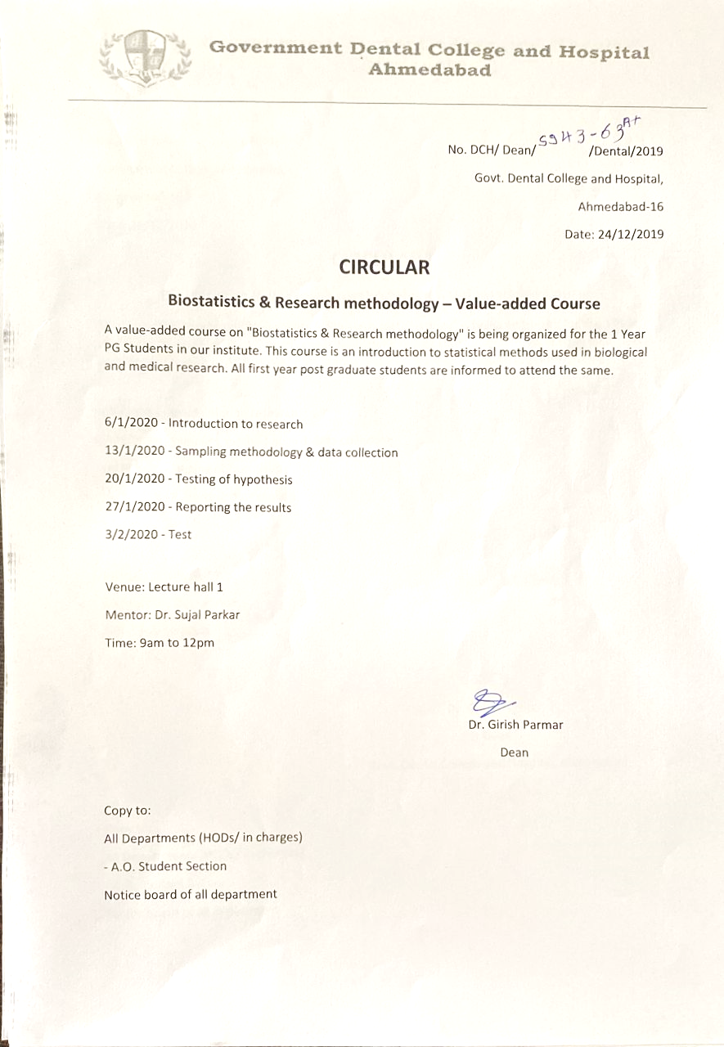
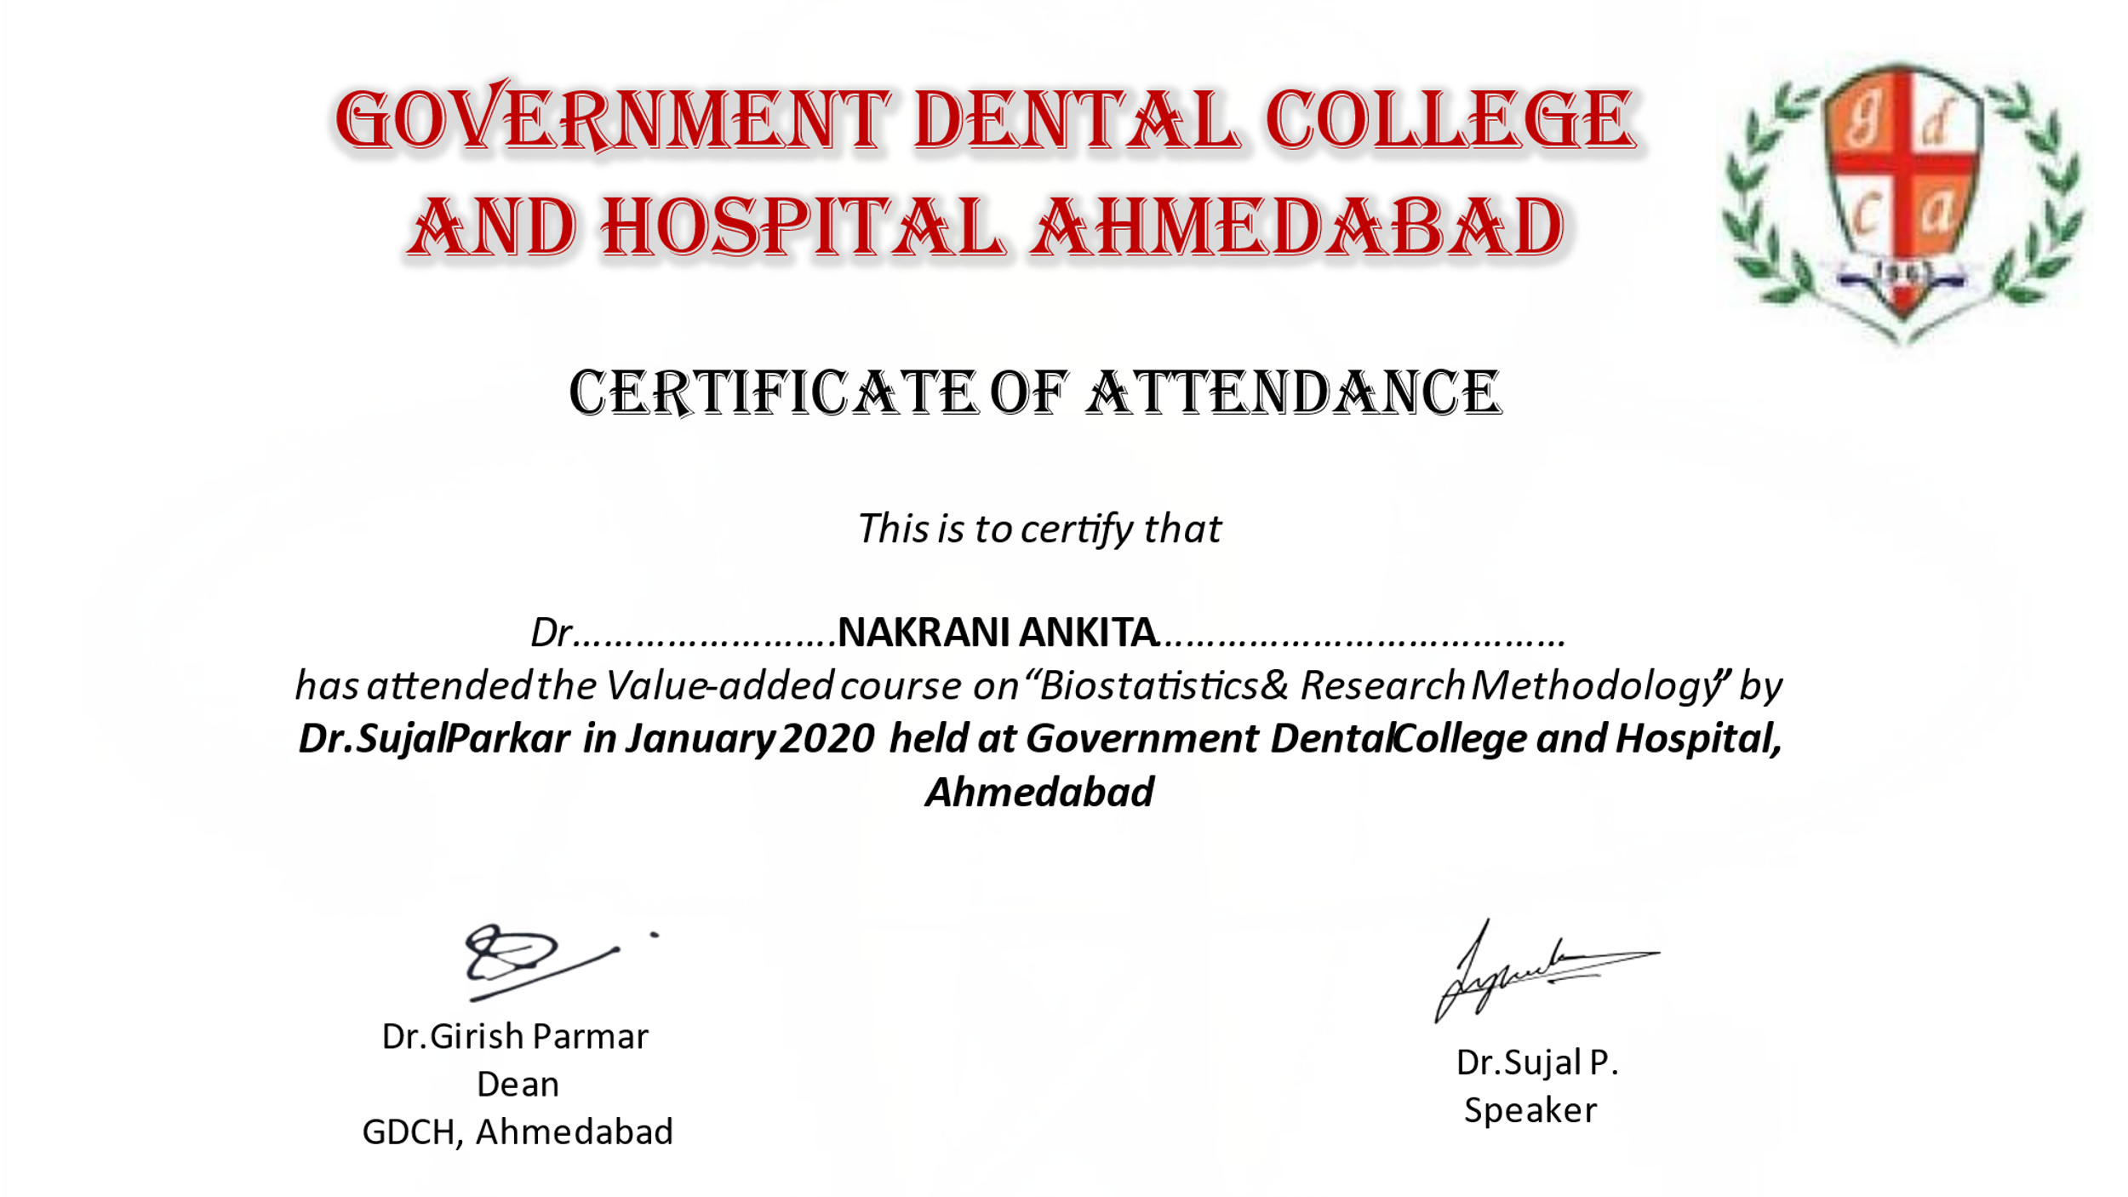

REPORT OF THE EVENT

This course focuses on Biostatistics and Epidemiology in the medical/Dental Research and give a demonstrate knowledge and scientific research in health-related fields, including public health, and the development of novel methodologies for understanding statistical theory. It include Method of data collection, Survey design (including questionnaire and question design) and analyzing the data.

This course was attended by 32 students.

