Biostatistics & Research Methodology
January 2019
Value added course

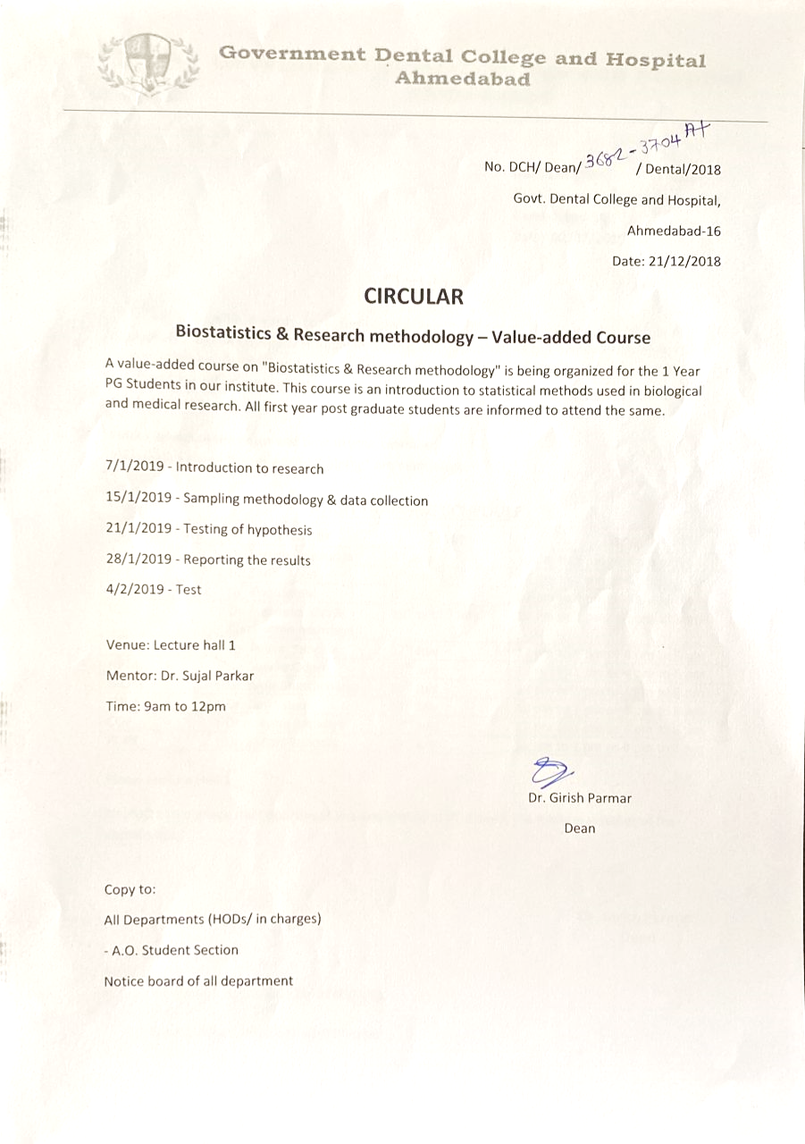

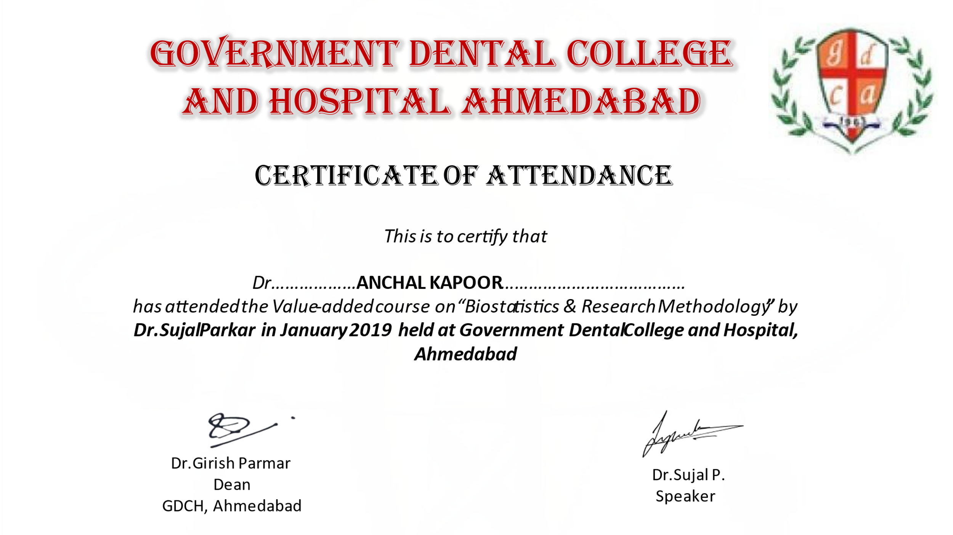

REPORT OF THE EVENT

This course focuses on the procedure to do quality research. As a researcher it is mandatory for one to know the basics and have a core idea in order to satisfy the purpose of research and establish an acceptable conclusion. This course has given this opportunity to the students to enhance the knowledge of biostatistics, their researching skills and understand the methodologies.

This course was attended by 30 students.
