REPORT ON FEEDBACK RECEIVED FROM ALUMNIES

- A questionnaire was prepared to make a survey on various parameters of Government Dental College and Hospital, Ahmedabad and same was filled by the alumnies of the college in the year 2017-2018.
- The questionnaire consisted of 10 questions which were based primarily on attributes of curriculum/syllabus, facilities provided, syllabus covered, aspects covered beyond curriculum, etc. Alumni were asked to rate each question in 1 to 10 scale. In the given survey held in 2017-2018, GDCH, Ahmedabad collected feedback from alumnies.
- The responses were analyzed in order to take corrective actions in relation to institutional vision and mission.
- The elaborative questionnaire along with its evaluation is given below:

- ENTIRE SYLLABUS COVERED AS PRESCRIBED BY THE UNIVERSITY

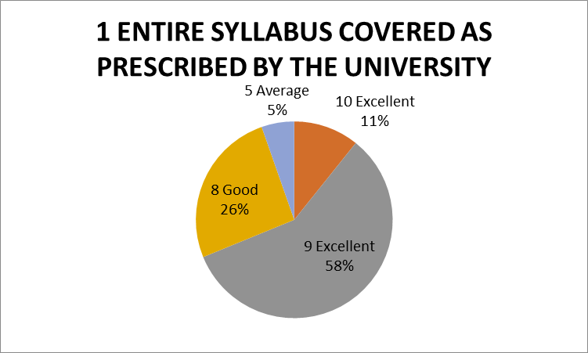
The given chart shows the percentage of respondents. 69% of Alumni rated excellent,26% alumni reported as good and 5% of them reported average about entire syllabus covered as prescribed by the university.

- THE CONTENT OF THE COURSE WAS RELEVANT
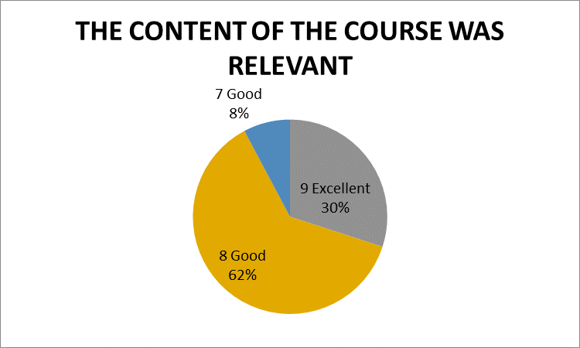
The given chart shows the percentage of respondents. 30% of alumni rated excellent,70% students reported as good about the relevance of the content of the course.
- ABILITY TO INTEGRATE TOPICS BEYOND CURRICULUM TO PROVIDE A BROADER PERSPECTIVE FOR CAREER ENHANCEMENT
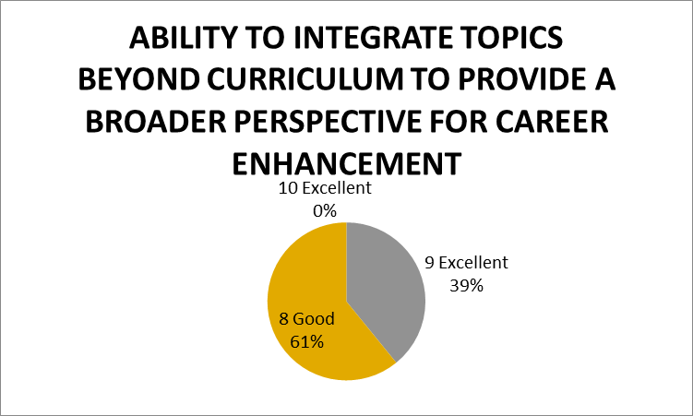
The given chart shows the percentage of respondents. 39% of alumni rated excellent,61% alumni reported as good average about the ability to integrate topics beyond curriculum.

- WHEN YOU MEET A STUDENT WHO HAS UNDERGONE SIMILAR PROGRAM FROM OUTSIDE THE INSTITUTE, YOUR PROGRAM WAS SUPERIOR/ INFERIOR IN TERMS OF THEORETICAL/ CLINICAL CONTENT
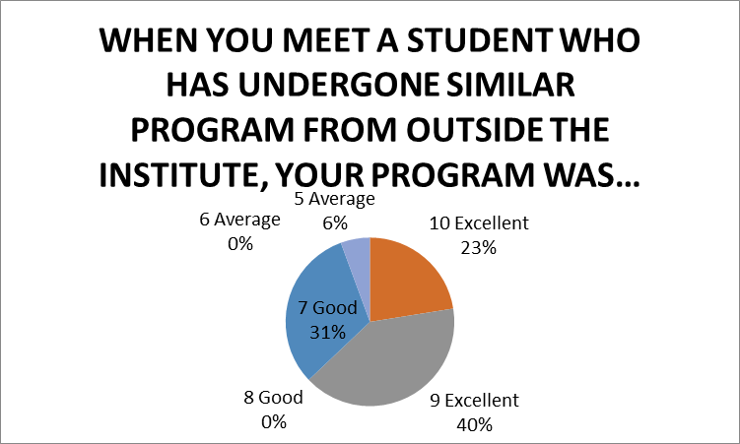
The given chart shows the percentage of respondents. 63% of alumni rated excellent,31% alumni reported as good and 6% of them reported average about the superiority of our program in relation

- FACILITIES PROVIDED IN TERMS OF INFRASTRUCTURE& AUDIOVISUAL AIDS
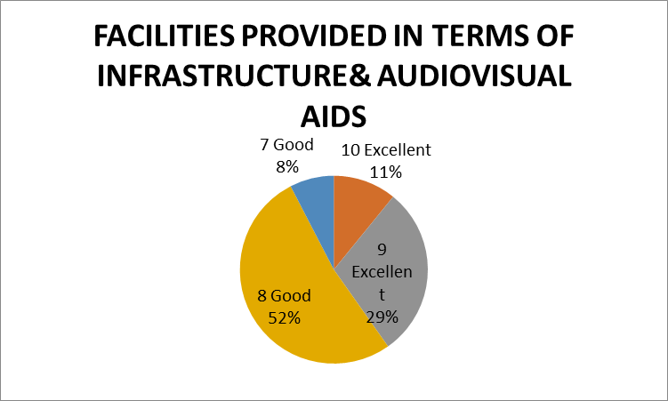
The given chart shows the percentage of respondents. 40% of alumni rated excellent,60% alumni reported as good about the facilities provided in terms of infrastructure and audiovisual aids

- AVALABILITY BEYOND NORMAL CLASSES AND CO-OPERATION TO SOLVE INDIVIDUAL PROBLEMS
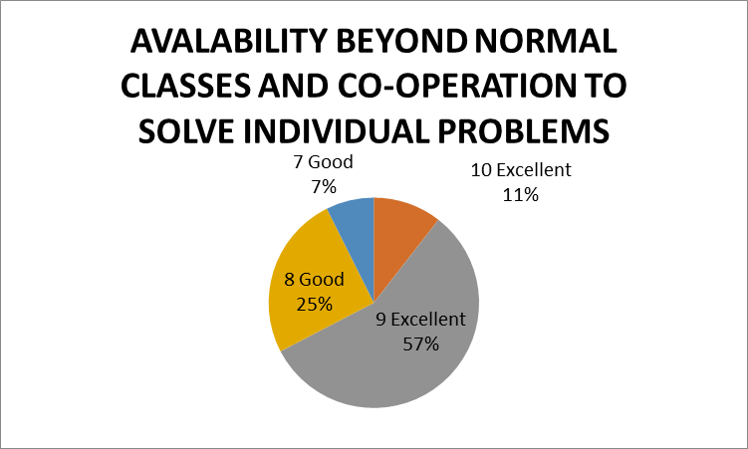
The given chart shows the percentage of respondents. 68% of faculty rated excellent,32% alumni reported as good about the availability of beyond normal classes and cooperation to solve individual problems.

- KNOWLEDGE GAINED AFTER COMPLETION OF COURSE

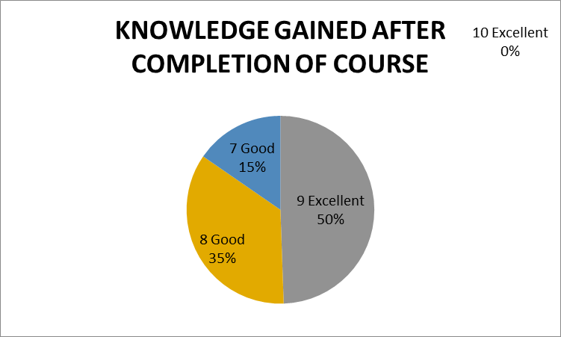
The given chart shows the percentage of respondents. 50% of faculty rated excellent,58% alumni reported as good and 9% of them reported average about the knowledge gained after completion of course.

- FAIRNESS IN EVALUATION IN ASSESSMENT/INTERNALS
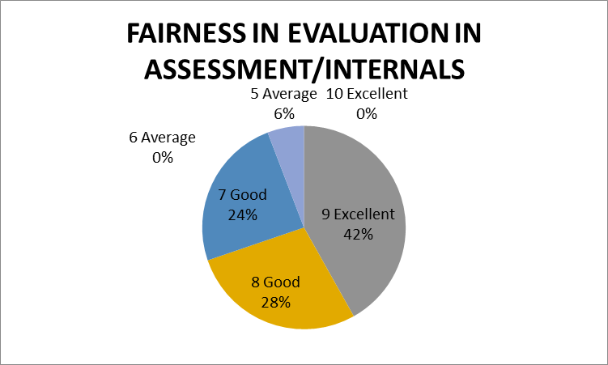
The given chart shows the percentage of respondents. 42% of faculty rated excellent,52% students reported as good and 6% of them reported average about the fairness in evaluation in assessment/ internals.

- AVAILABILITY OF RECENT TRENDS IN THE INSTITUTE
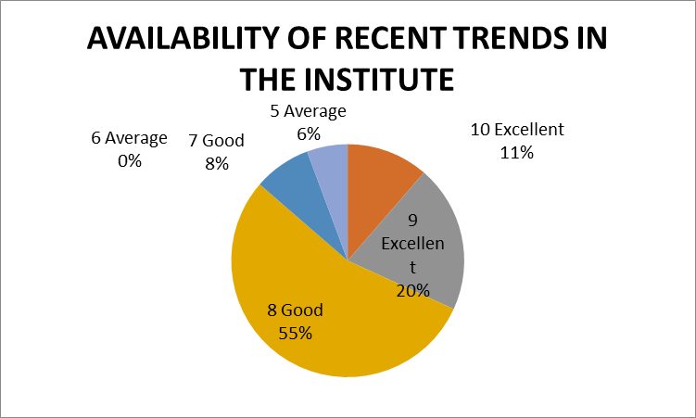
The given chart shows the percentage of respondents. 31% of alumni rated excellent,62% alumni reported as good and 6% of them reported average about the availability of recent trends in institute.

10.TIME ADEQUACY PROVIDED FOR THE COMPLETION OF COURSE
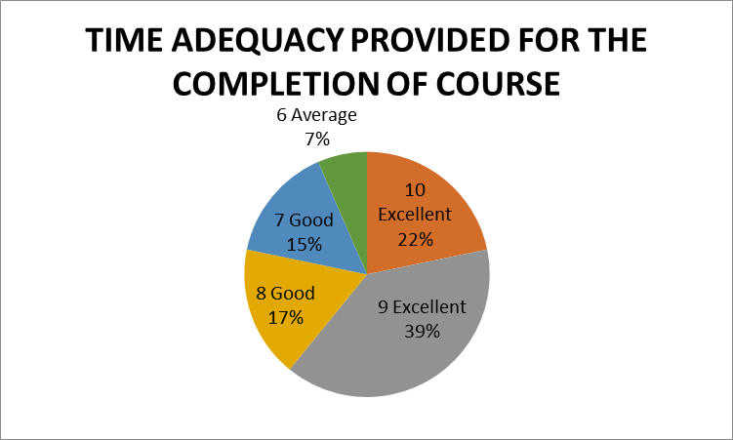
The given chart shows the percentage of respondents. 61% of alumni rated excellent,32% alumni reported as good and 7% of them reported average about the time adequacy provided for the completion of course.

