COVID-19 THIRD WAVE PREPAREDNESS
19-23 JULY 2021

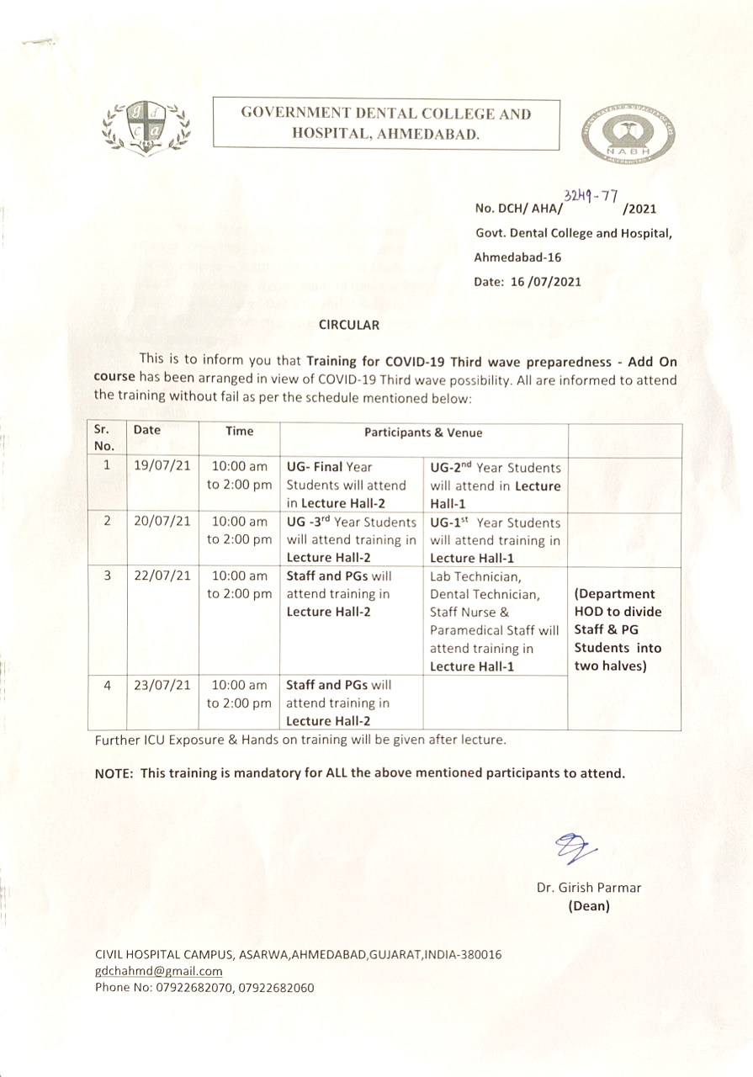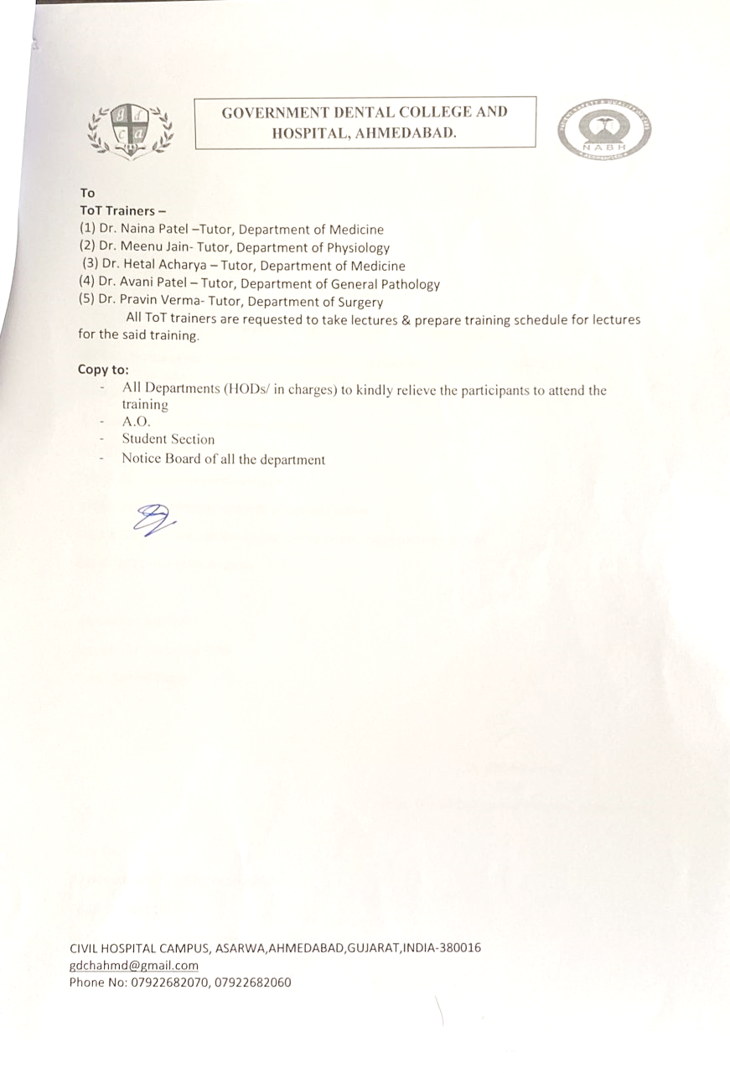

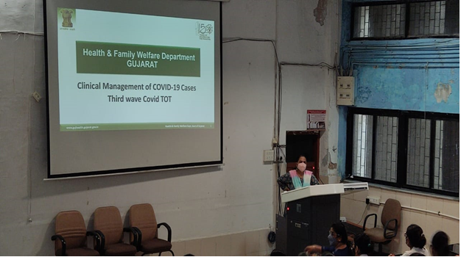
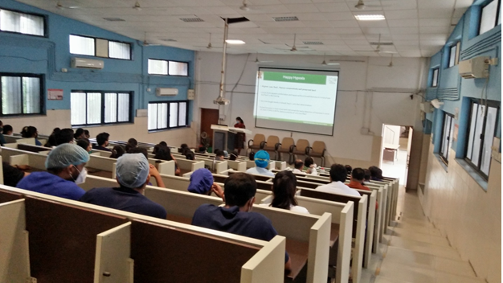
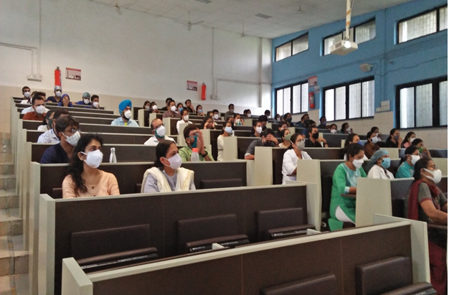

REPORT OF THE PROGRAMME
This event was organized by Government Dental College & Hospital, Ahmedabad in view of Covid-19 third wave possibility. The event was a 4-days programme with a session of 4 hours on each day. All the undergraduate & postgraduate students as well as the staff of GDCH, Ahmedabad has attended these sessions and upgraded their knowledge and skill for the management of Covid-19 Emergencies that were anticipated to come during the third wave.

