BIO 342
Comparative Vertebrate Anatomy
Lecture Notes 11 - Nervous System

The Vertebrate Nervous System:
1 - receives stimuli from receptors & transmits information to effectors that respond to stimulation
2 - regulates behavior by integrating incoming sensory information with stored information (the results of past experience) & translating that into action by way of effectors
3 - includes billions of nerve cells (or neurons), each of which establishes thousands of contacts with other nerve cells
4 - also includes neuroglia cells that support, nourish, & insulate neurons
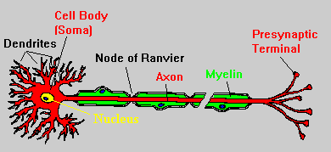
Subdivisions of the Vertebrate Nervous System:
1 - Central Nervous System - including the brain & spinal cord
2 - Peripheral Nervous System - including cranial nerves, spinal nerves, & all branches of cranial & spinal nerves
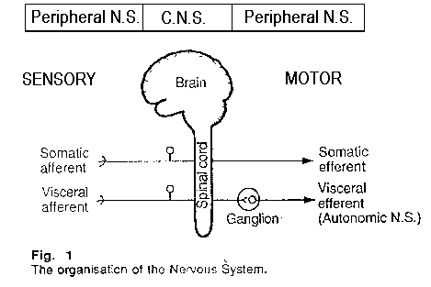
Source: http://www.david.curtis.care4free.net/neurons.htm
Neurons (or nerve cells):
- respond to stimuli & conduct impulses
- 3 types - all with cell body & processes (axons & dendrites):
  - multipolar
  - bipolar
  - unipolar
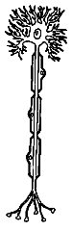  Multipolar neuron |   Bipolar neuron | 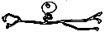  Unipolar neuron
Nerves = bundles of nerve cell processes; may be sensory, motor, or mixed

Spinal cord:
- located in vertebral canal
- anatomical beginning is the foramen magnum of the skull
- length varies among vertebrates:
  - in vertebrates with abundant tail musculature, the spinal cord extends to the caudal end of the vertebral column
  - in vertebrates without tails or without much tail musculature, the spinal cord extends to about the lumbar region of the vertebral column
- a cross-section of the spinal cord reveals gray matter & white matter. The gray matter consists of nerve cell bodies, while the white matter consists of nerve cell processes (axons). These processes make up ascending (sensory) and descending (motor) fiber tracts.
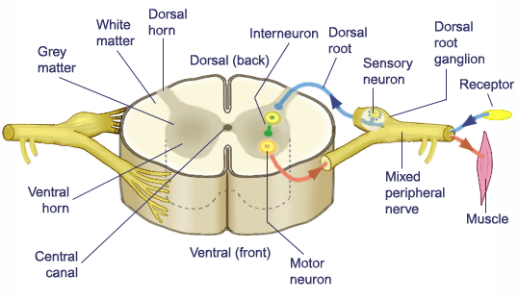
Used with permission of G. Mandl
Spinal nerves:
- arise from spinal cord by dorsal & ventral roots. The dorsal root exhibits a ganglion & is sensory, while the ventral root has no ganglion & is motor.
- early vertebrates:
  - dorsal & ventral roots did not unite
  - dorsal roots were mixed (contained both sensory & motor fibers)
  - no dorsal root ganglion
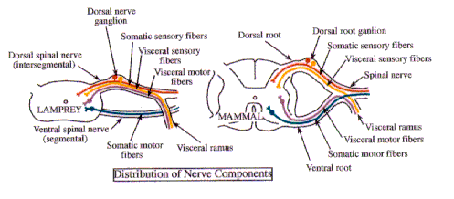
- Rami - 2 branches of each spinal nerve:
  - dorsal ramus - supplies epaxial muscles & skin of the dorsal part of the body
  - ventral ramus - supplies hypaxial muscles & skin of the side & ventral part of the body
- Functional types of neurons in spinal nerves (& other nerves):
  - somatic afferent - sensory from general cutaneous receptors (in the skin) & proprioceptors (in skeletal muscles, tendons, & joints)
  - somatic efferent - motor to skeletal muscles
  - visceral afferent - sensory from receptors in the viscera (smooth muscle, cardiac muscle, & glands)
  - visceral efferent - motor to smooth muscle, cardiac muscle, & glands
Brain:
- the anterior end of the embryonic central nervous system exhibits 3 primary sections:
  - prosencephalon (forebrain) - subsequently divides into the telencephalon (cerebrum) & diencephalon (epithalamus, thalamus, & hypothalamus)
  - mesencephalon (midbrain) - develops without further subdivision & forms the tectum
  - rhombencephalon (hindbrain) - subdivides into the metencephalon (pons & cerebellum) and myelencephalon (medulla oblongata)
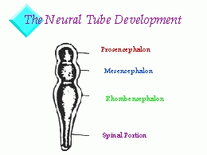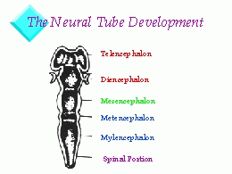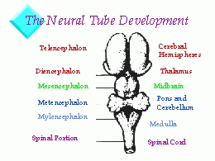

Source: http://brainmuseum.org/development/index.html
- Phylogenetic trend in vertebrate brains is for enlargement of forebrain:
  - increasingly complex behaviors & muscle control:
    - coordination of limb movements more complicated (e.g., bipedal dinosaurs & birds)
    - increased input of sensory information & increased output of motor responses
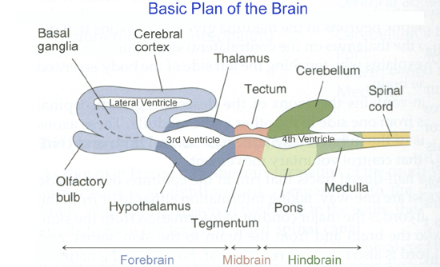
Source: http://www.colorado.edu/epob/epob3730rlynch/image/figure5-1.jpg
Myelencephalon - consists of the medulla oblongata & its major functions include:
- origin of cranial nerves (VII - X or VII - XII)
- pathway for ascending & descending fiber tracts
- contains centers important in regulating respiration, heartbeat, & intestinal motility
Metencephalon - consists of the pons & cerebellum:
- Pons - pathway for ascending & descending fiber tracts & origin of cranial nerves V, VI, & VII
- Cerebellum - modifies & monitors motor output:
  - important in maintaining equilibrium
  - coordinates & refines motor action
Mesencephalon - consists of the tectum which includes the optic lobes & auditory lobes:
- optic lobes - receive fibers from retina; vary in size with relative importance of vision
- auditory lobes - receive fibers from inner ear
Diencephalon - consists of the epithalamus, hypothalamus, & thalamus:
- epithalamus - includes pineal gland (epiphysis) that affects skin pigmentation (by acting on melanocytes) in lower vertebrates & plays a role in regulating biological rhythms in higher vertebrates
- hypothalamus - regulates body temperature, water balance, appetite, blood pressure, sexual behavior, & some aspects of emotional behavior
- thalamus - major coordinating, or relay, center for sensory impulses from all parts of the body
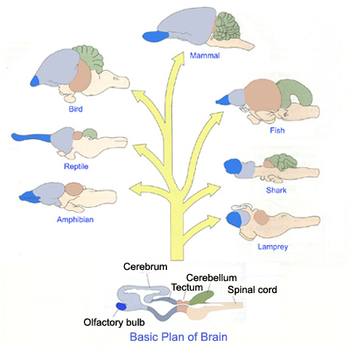
Source: http://www.colorado.edu/epob/epob3730rlynch/image/figure5-4.jpg
Telencephalon - consists of the cerebrum which, in turn, consists of 2 cerebral hemispheres
- cerebrum has 2 regions: a dorsal PALLIUM (with medial, dorsal, & lateral divisions) & a ventral SUBPALLIUM (consisting of a striatum & a septum)
- all vertebrates have a cerebrum based on the same basic plan; major phylogenetic changes are due to loss, fusion, or enlargement of the various regions.
  - medial pallium receives olfactory information
  - dorsal & lateral pallia receive other sensory input (including visual & auditory information relayed from the thalamus)
- agnathans, fish, & amphibians - pallia are similar
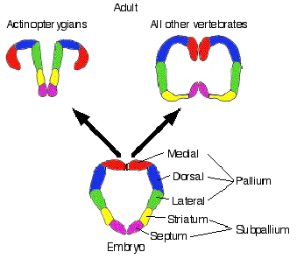
Source: http://www.auburn.edu/academic/classes/zy/0301/Topic19/Topic19.html
- reptiles - pallium has 3 main divisions (medial, dorsal, & lateral) but also has a large DORSAL VENTRICULAR RIDGE (DVR), derived from lateral pallium; DVR may be higher association area
- birds - DVR expands further; dorsal part increases in size & is called the WULST; as in reptiles, the DVR appears to serve as a higher association area
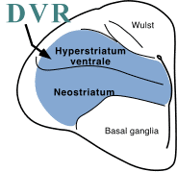
Source: http://www.pigeon.psy.tufts.edu/avc/husband/avc2amnt.htm
- mammals - do not have enlarged DVR but DORSAL PALLIUM is enlarged & is called the CEREBRAL CORTEX; cortex receives & analyzes sensory information & initiates motor activity
- subpallium:
  - septum - important part of the limbic system (regulates emotions & plays vital role in short-term memory)
  - striatum - also called basal ganglia; present in all vertebrates & controls sequence of actions in complex movements

Cranial nerves - agnathans, most fish, & living amphibians have 10 cranial nerves; crossopterygians & amniotes have 12:
- Olfactory nerve (I) - sensory nerve; sense of smell
- Optic nerve (II) - sensory ‘nerve’; sense of vision
- Oculomotor nerve (III) - motor nerve to extrinsic eye muscles
- Trochlear nerve (IV) - motor to extrinsic eye muscles
- Trigeminal (V) - mixed nerve; sensory from skin of head & mouth (including teeth) & motor to muscles of 1st pharyngeal arch (muscles of jaw)
- Abducens (VI) - motor to extrinsic eyeball muscles
- Facial (VII) - mixed nerve; sensory from lateral line of head, ampullae of Lorenzini, & taste buds; motor to muscles of hyoid arch
- Auditory (VIII) - sensory from inner ear (balance & hearing)
- Glossopharyngeal (IX) - mixed nerve; sensory from taste buds & lateral line; motor to muscles of 3rd arch
- Vagus (X) - mixed nerve; sensory from & motor to heart, anterior digestive system, mouth, gill pouches 2 - 5, & lateral line
- Accessory nerve (XI) - motor to derivatives of cucullaris muscle (cleidomastoid, sternomastoid, & trapezius)
- Hypoglossal nerve (XII) - motor to hyoid & tongue muscles
Possibly useful mnemonics to aid in memorization of cranial nerves: “On Old Olympus Towering Top A Finn And German Viewed A Hop” or “Oh, Once One Takes The Anatomy Final, A Good Vacation Appears Heavenly.”
Sensory Organs
Sensory receptors:
- monitor the external & internal environment by responding to selected stimuli, then ‘translating’ those stimuli into nerve impulses
- Types of sensory organs:
  - somatic sensory organs - provide information about the external environment
  - visceral sensory organs - provide information about the organism's internal environment
  - general sensory organs - widely distributed over the surface & interior of the body
  - special sensory organs - confined to the head (amniotes & terrestrial amphibians)
Special Somatic Receptors
- Neuromast organs ('groove organ' below in Figure 10-4)
  - receptors in skin of fishes & aquatic amphibians that detect water currents & ‘hear’ sounds
  - occur singly, in groups, or in a linear series (e.g., lateral lines)
  - may also be modified to detect electricity (ampullae of Lorenzini)
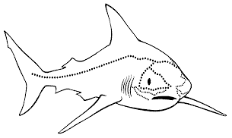
Shark lateral line system

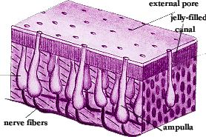

The ampullae of Lorenzini are small vesicles that form part of an extensive subcutaneous sensory network system. These vesicles are found around the head of the shark. They detect weak magnetic fields produced by other fish at short ranges. This enables a shark to locate prey buried in the sand or to orient to nearby movement. Each ampulla is a bundle of sensory cells innervated by several nerve fibers. These fibers are enclosed in a jelly-filled tubule that has a direct opening to the surface through a pore. These pores on the head of the shark are visible to the naked eye, and appear as dark spots. | 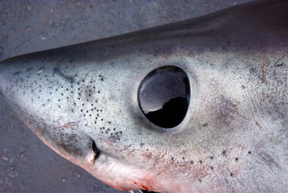

- Neuromast organs have 2 types of cells:
  - hair cells (receptor cells) - each hair cell has several short cilia & kinocilia that project into fluid or a cupula (displacement of cupula & cilia generates nervous impulses)
  - supporting cells
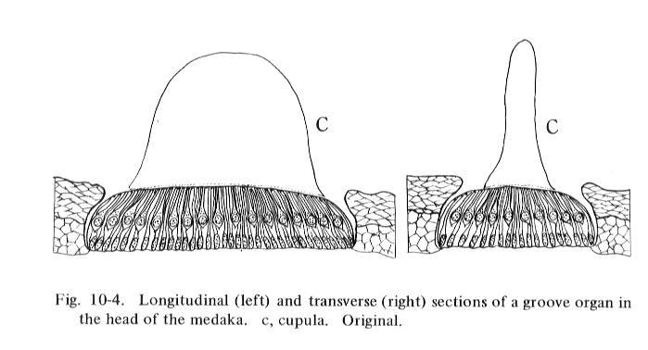
- Membranous labyrinth
  - exhibited by all vertebrates
  - fluid-filled & embedded in skull lateral to hindbrain
  - Labyrinth usually consists of 3 semicircular canals, a utriculus, & a sacculus
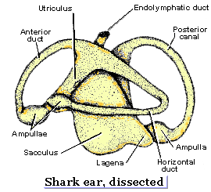
Semicircular canals:
- Hagfish - have only one (posterior)
- Lamprey - have 2 (anterior & posterior)
- Other vertebrates - have 3 (anterior, posterior, & horizontal)
Functions of the labyrinth:
1 - Equilibrium
- Dynamic equilibrium - when head moves, inertia causes a slight relative movement of fluid in at least one semicircular canal ---> deflects cupula (in ampulla) ---> nervous impulses
- Static equilibrium - maculae (in sacculus & utriculus) tilt when head moves ---> nervous impulses
2 - Hearing - function of ORGAN OF CORTI located in lagena (enlargement of sacculus); lagena tends to be longer in terrestrial vertebrates &, in most mammals, it’s coiled into the cochlea. The organ of Corti contains a specialized strip of neuromasts connected to the nervous system via the auditory nerve.
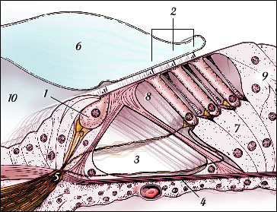
1-Inner hair cell, 2-Outer hair cells, 3-Tunnel of Corti, 4-Basilar membrane, 5-Reticular lamina,
6-Tectorial membrane, 7-Deiters' cells, 8-Space of Nuel, 9-Hensen's cells, & 10-Inner spiral sulcus
[Drawing by Stephan Blatrix, from "Promenade around the cochlea" by R Pujol, S. Blatrix, T. Pujol and V. Reclar-Enjalbert, CRIC,
University Montpellier 1 - INSERM. URL: http://www.iurc.montp.inserm.fr/cric/audition/english/corti/fcorti.htm]
Hearing:
- Outer ear of tetrapods:
  - Amphibians & most reptiles - eardrum (tympanic membrane) is on surface of the head
  - Crocodilians, birds, & mammals - eardrum is deeper in the skull at the end of an air-filled passageway called the outer ear canal (or external auditory meatus)
  - Mammals - pinna collects & directs sound waves
- Middle ear of tetrapods - cavity plus ossicle(s):
  - Amphibians, reptiles, & birds - single middle ear ossicle (columella or stapes)
  - Mammals - 3 middle ear ossicles (malleus, incus, & stapes)
- Inner ear = labyrinth, including lagena (or cochlea)

How do pressure or sound waves become ‘sound?’
(Also: check out http://www.iurc.montp.inserm.fr/cric/audition/english/ear/fear.htm &
http://www.blackwellscience.com/matthews/ear.html)

Pit receptors of reptiles = infrared receptors:
1 - Labial pits
- found in pythons (Family Boidae); nerve endings lie at the bottom of several recessed labial pits
- permit detection of a mouse about 15 cm away
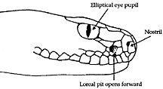
2 - Loreal pits
- also called facial pits; can detect temperature changes of as little as 0.001 degree C & so can detect prey several feet away
- present in snakes in the family Crotalidae (North American rattlesnakes, copperheads, & water moccasins), also called the pit vipers
Light receptors (or photoreceptors) - vertebrates can perceive only a narrow band of electromagnetic radiation between about 350 & 760 nm; 2 types include the epiphysis (already described) & the eye
Structure of a vertebrate eye:
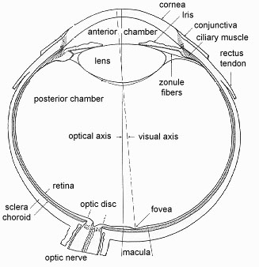
Accommodation is the process of focusing light on the retina & this can occur in several different ways:
- Lamprey - contraction of corneal muscle pulls cornea against the lens & moves the lens
- Teleosts (bony fish) - retractor muscle attached to lens (rectractor lentis muscle) moves lens posteriorly
- Amphibians & cartilaginous fish - protractor muscle attached to lens pulls the lens forward for near vision
- Snakes - increased pressure in the vitreous humor generated by muscles near the iris pushes the lens forward
- Most reptiles, birds, & mammals - curvature of lens is altered by ciliary (annular) muscles
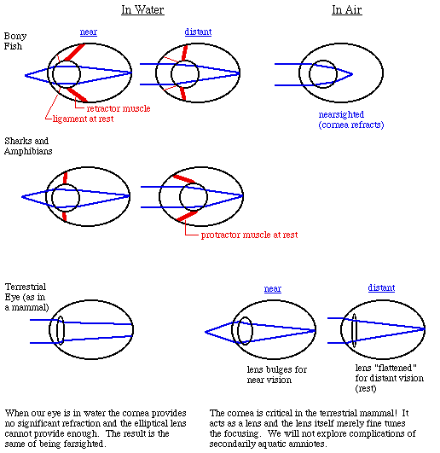

Special visceral receptors - olfactory (smell) & gustatory (taste):
- Olfaction - involves receptors located in nasal passages; olfactory epithelium contains basal cells (replacement cells), supporting cells (secrete mucus), & olfactory receptor cells
- vomeronasal organs - only in tetrapods but absent in most turtles, crocodiles, birds, some bats, primates, & aquatic mammals:
  - amphibians - recessed area off the main nasal cavity
  - reptiles - separate pit to which tongue & oral membranes deliver chemicals
  - mammals:
    - isolated area of olfactory membrane within nasal cavity that is connected to mouth via a nasopalatine duct
    - well-developed in monotremes, marsupials, insectivores, & many carnivores
  - function of vomeronasal organs - may be especially important in detecting conspecific odors, but also useful in prey detection
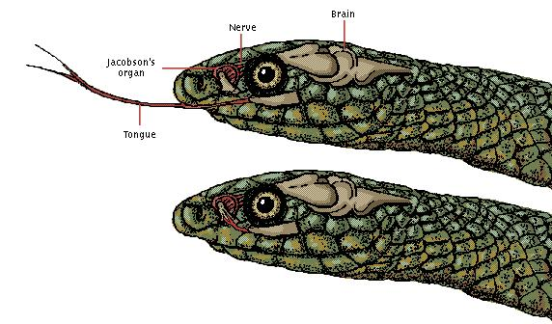
- Gustation (taste) - taste buds, like olfactory receptors, detect chemical stimuli
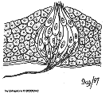
  - Taste buds
    - consist of supportive cells & taste cells
    - distribution:
      - Fish - widely distributed in roof, walls, & floor of pharynx; bottom feeders & scavengers (catfish & carp) have taste buds distributed over entire surface of head & body, especially on the barbels (‘whiskers’)
      - Tetrapods - taste buds restricted to tongue, posterior palate, & oral pharynx
General Somatic Receptors - come in two categories: cutaneous receptors & proprioceptors
- cutaneous receptors (for touch, pressure, pain, & temperature)
  - naked endings - in skin of all vertebrates; stimulated by contact
  - encapsulated endings - present in tetrapods; nerve endings wrapped in a connective tissue capsule
    - Herbst corpuscles - on beak, tongue, & palate of water birds
    - end bulbs & Ruffini corpuscles - thermal receptors in mammals
    - Pacinian corpuscles - touch & pressure receptors
- proprioceptors - located in skeletal muscles, joints, and tendons & provide information about body position
General Visceral Receptors:
- mostly naked endings in mucosa of the tubes, vessels, & organs of the body, in cardiac muscle,& in smooth muscle; chiefly stretch & chemoreceptors
- some functions of general visceral receptors:
  - monitor oxygen & carbon dioxide content of blood
  - monitor blood pressure (baroreceptors in Figure 1 below)
  - monitor concentration of solutes in blood
- similar among all vertebrates
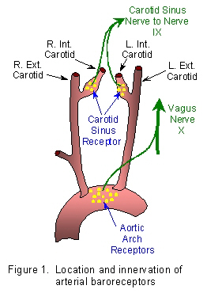

Useful links:
Comparative Anatomy of the Chordate Nervous System
Comparative Anatomy Topic 19: The Nervous System
Coordination and Integration
Evolution of the Amniote Brain
Sensory Mechanisms
The Evolution of the Vertebrate Brain

Back to BIO 342 Syllabus

