NIL HARSHAD SATYAVIJAY

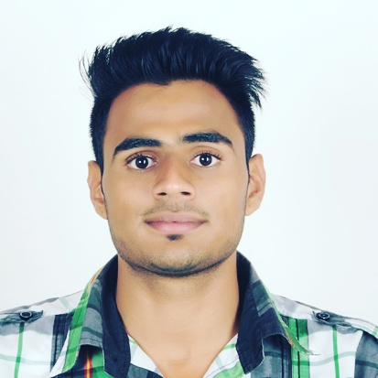

PERSONAL PROFILE :

NAME:
Nil Harshad Satyavijay

DATE OF BIRTH:
18TH November 1995

BLOOD GROUP:
A +ve

GENDER:
Male

MARITAL STATUS: Unmarried

NATIONALITY:
Indian

E-Mail :- hashmech1995@gmail.com
Add :-Chinchwad Tal-Haveli Dist-Pune.
Cell :-8600425955/8668380071

CAREER OBJECTIVE:

To be a part of a Hi-tech organization and to work with community of dedicated people. I am looking to improve my position in the work force, expand my knowledge and skills.

ACADEMIC PROFILE :

Qualification | Institute | Board/  University | Passing Year | %
B.E Mechanical | GS MOZE College of Engg& Research, Pune. | Pune  University. | 2017 | 65.86%
H.S.C | Mahalsakant JR College,Akurdi pune | Maharashtra state  board | 2013 | 61.21%
S.S.C | Navmaharashtra  Vidyalaya pimpri | Maharashtra  State  Board | 2011 | 84.00%

WORK EXPERIENCE :

I have done internship in Plastic Product development in Parametric technology chinchwad pune.

- Work on Pillar design.
- Knowledge of A to B coversion, Close Volume ,Draft analysis,Tooling
- direction.
- Design of Bosses,Locator,Clip tower
- Knowledge of Power copy,Advance surfacing(swept,Blend)
- 2D drafting

SOFTWARE SKILLS:

- Catia V5 R20
- Creo parametric
- UGNX (Good basic knowledge)
- AUTOCAD or ZWCAD

LANGUAGES :

- English.
- Hindi.
- Marathi.

PROJECT :
Name :- Design of Overload Torque Limiter With
Electromechanical Clutch.
Role :- Testing.
Description :- : The purpose of this project is to avoid a damage of shaft,To avoid engine burn out when overload is apply on its output member.Motor from the output member is absolutely necessary to avoid damage & its possible by called electromechanical clutch.When overload occurs the TORQUE LIMITER will reliably & quickly release to prevent syestem damage

EXTRA CURRICULAR ACTIVITIES :

- Participated in ZEST Which is organized by COEP
- Participated & succsesfully organized Umang 2015 & 2016 as a team leader.
- Participated in QFL compition in 2017 which is organized by MILLIONAIRE MENTOR (U.S)
- Won the First prize for the event BOX CRICKET in Umang 2015
- Won the Second prize for the event KABBADI in Umang 2016

INTERPERSONAL SKILL :

- Ability to rapidly build relationship and set up trust.
- Highly motivated and Eager to learn new things.
- Ability to produce best result in pressure situation.
- Excellent communication and presentation skills.
- Ready to accept any challenge irrespective of its complexity.

STRENGTH :
- Willing to Work in a team & as an individual whenever needed.
- Strong communication skill
- Always Ready to learn new skills
- Self motivated.
- Leadership Quality
Weakness :
- Difficult to work with negative minded people.
- I care too much about my work
HOBBIES INTERESTS

- Nonveg Cooking 1) Innovation
- Reading motivational story 2) Startup
- Making Inspirational Quotes 3) Implimentation
- Spread Positive Vibes in Society 4) Entrepreneurship
DECLARATION

I here by declare that the above furnished details are true and correct to the best of my knowledge and I bear the responsibility for the correctness of the above mentioned particulars.

DATE: 10/3/2018

PLACE: Pune. Your Faithfully

Harshad Satyavijay Nil

