 | ARUN KUMAR  Mob: +919794874183 , 8920269989  Email Id:lovearun1992@gmail.com |  |  |  |  | 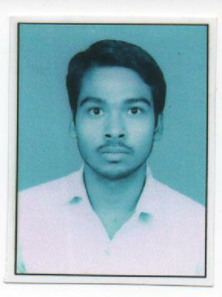
CAREER OBJECTIVE:
Looking for an entry into a world class, highly professional organization with challenging and competitive environment where I can use my knowledge base as well as personal attributes to achieve the organizational goals.

 | ACADEMIC  QUALIFICATION | STANDARD | BOARD/ UNIVERSITY | SCHOOL/COLLEGENAME |  | PERCENTAGE
 | ACADEMIC  QUALIFICATION | B-TECH-Mechanical Engineering  (2012-2016) | UPTU, | College of Engineering & Rural Technology, Partapur Meerut. |  | 67% | 65
 | ACADEMIC  QUALIFICATION | XII  (2010) | U.P  Board | G.P.S Inter College chaurichaura Gorakhpur(U.P) |  | 67%
 | ACADEMIC  QUALIFICATION | X  (2008) | U.P  Board | G.P.S Inter College ChauriChauraGorakhpur(U.P) |  | 60%
 | KEY SKILLS | - Self driven & enthusiastic.  - Inquisitive & faster effectively.  - Loyal and disciplined towards duties.  - Positive attitude.
 | WORK EXPERIENCE | - experience in jindal sow ltd
 | SUBJECTS/ AREAS OF INTEREST | - Production and automobile
 | TECH NICAL PROFICIENCY  &  TOOLS EXPERTISE | - Operating System :WindowsXp,Window 07,Window 08.  - Software Skills:MS-Office,  - Automation :Auto-CAD,c++,c.
 | PROJECTS UNDERTAKEN | - Project Name: “Automatic Vhelicalstand ”.  - Hardware Used:relay,stand,battery,capacitor,motar,  etc .
 | VOCATIONAL  TRAINING | - 1 month training in “ YANTRIKI KARKHANA GORAKHPUR RAILWAY(U.P)”.  (Period: June-July, 2014)  Title : BEARING. |  |  | - Completed summer training in one month“ YANTRIKI KARKHANA GORAKHPUR RAILWAY).  (Period: June-July, 2015)
 | PERSONAL ATTRIBUTES | - Good communication skill, personal management Skill.  - Able to work independently under pressure with flexibility and frompart of a team.  - Able to take initiatives and work in planned manner to achieve the defined targets.
 | PERSONAL DETAILS | Name : Arun Kumar  Father’s Name : LateDeep Chandra  Date of Birth : 10/09/1992  Sex : Male  Nationality : Indian  Marital Status : Unmarried  Language Known : English & Hindi.  Permanent Address : Vill-mahdeva jungle, Post-chauri chauradist-  Gorakhpur (U.P).:-

DECLARATION: I hereby declare that the above information are best of my knowledge & belief.

DATE : (ARUN KUMAR)
PLACE : KUTCH

