Danish Nagar D-3/643
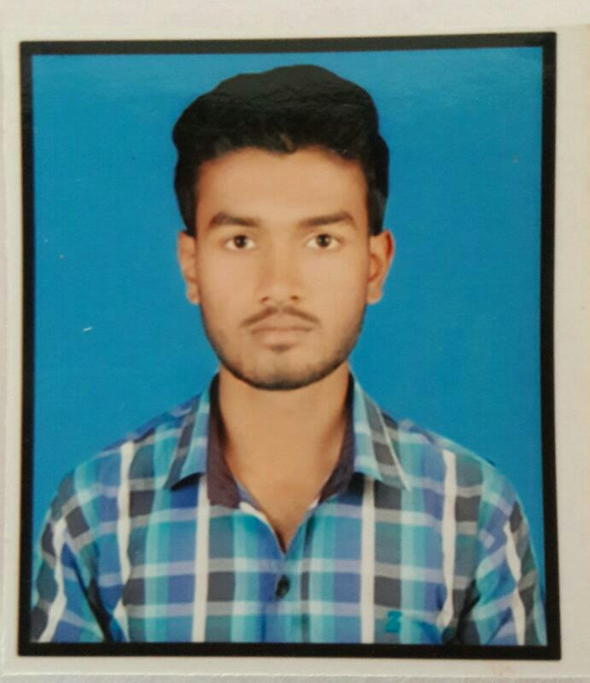
Bhopal
Madhya Pradesh
Pin code: 462026
Mob: +919661170598
Email: rajansatya1996@gmail.com

RAJAN KUMAR BAITHA

CAREER OBJECTIVES:

As a fresh mechanical engineer, I continue with an open mind, full of creativity and commitment to understand business requirements, patiently learn and contributes
to the growth of organization as an engineer. My application knowledge, analytical
and interactive skills will be an asset that can be a part to optimum use.

QUALIFICATIONS:

EXAMINATION | UNIVERSITY/BOARD | PASSING YEAR | DIVISION | PERCENTAGE(%)
10th | BSEB PATNA | 2013 | 2ND | 52
DIPLOMA (Mech) | AISECT University | 2017 | Pursuing

STRENGTH& SKILLS:

- Honesty.
- Hard working.
- Teamwork.
- D.C.A
- Electrician House wiring
- Microsoft Office
- National Service Scheme (NSS)
- Entrepreneurship Awareness camp (EAC)
- Project “Air Cooled Heat Exchanger”

HOBBIES:

- Listening Music.
- Cooking
- Watching Movies

COMMUNICATION:

- Hindi.
- English
- Bhojpuri

PERSONAL DETAILS: | FATHER’S NAME: Mr. PABARU BAITHA

MOTHER’S NAME: Mrs. USHA DEVI
D.O.B: 05/02/1996
AGE: 21 Yrs.
GENDER: MALE
RELIGION: HINDU
NATIONALITY: INDIAN

MARITAL STATUS: UNMARRIED

DECLARATION:

I hereby declare the above information is absolutely correct and true to the best of my knowledge.

PLACE:
DATE:
Mr. Rajan Kumar Baitha

