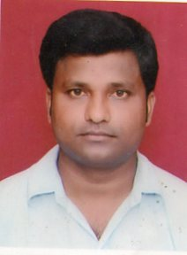
RESUME

Full Name : Rajesh Kumar Dusadh
Address for correspondence : Vill- Karanjahwa, Post- Dohariya Bazar
Distt – Gorakhpur (U.P.) 273015
Phone : 8081374141,9452969955
Email : erdusadh@gmail.com

Career Objective
Intend to build a career with leading corporate of hi-tech environment with committed & dedicated people. which will help me to explore myself fully and realize my potential.

Academic Background :
Year (s) | Qualification Degree/Diploma/  Certificate | Board/University | College  Institute/University | Percentage
2008 | 10th | UP BOARD | MMM HSS SKN | 57.16
2010 | 12th | UP BOARD | BYS IC GORAKHPUR | 68.20
2016 | B.Tech (ME) | DR APJAKTU  LACKNOW | VIT KANPUR | 60.26

Working Experience :

Fresher.

Training : (Duration-1Month)

Mechanical workshop, N.E. Railway, Gorakhpur.

Project :

Robotic Arm.

Computers Skills:

Basic knowledge of computer.

Personal Details :

Date of Birth (DD-MM-YYYY) : 10 Feb 1990
Father’s Name : Mr. S P Dusadh
Mother’s Name : Mrs. Ramrati Devi
Category : SC
Gender : Male
Nationality : Indian
Home Town : Gorakhpur
Permanent Address : Vill-Karanjahwa, Post- Dohriya Bazar, Distt- Gorakhpur (UP) 273015

I declare that details above are correct and true to best of my knowledge

Full Name: Rajesh Kumar Dusadh

