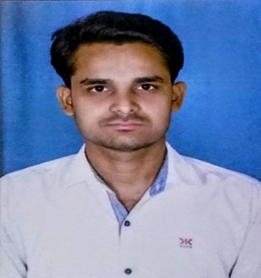
NANDAN KUMAR
H.NO-121 KUMHARTOLI,
PS+PO: -MASAURHI
DISTT: -PATNA
BIHAR-804452
GMAIL ID: -nandanpatel1451@gmail.com

CAREER OBJECTIVE
To be a part of an organization where I can fully utilize my skills, make a significant contribution to the success of the employer, and at the same time my individual growth.

ACADEMIC DETAILS:
S.NO | DEGREE/COURSES | INSTITUTION | YEAR OF PASSING | PERCENTAGE  /GRADE
1. | 10TH | BSEB BOARD PATNA | 2011 | 70.4%
2. | 12TH | BSEB BOARD PATNA | 2014 | 62.8%
3. | B.E  (MECHANICAL) | RGPV BHOPAL | 2018 | 6.92 (CGPA)

WORK EXPERIENCE :- ( 01/06/2018 TO 5/01/2019)
Graduate in Mechanical Engineer with 6 Month of experience in High-pressure die casting of automobile component Manufacturing. Working with Helios syscom private limited Rajkot in Quality assurance team as a lab assistant.

JOB RESPONSIBILITIES
- All working and management activities of Melting Shop, Mechanical and Chemical Lab.
- Monitoring Steel Melting Shop and mechanical and chemical testing performance on Daily basis read & analyses.
- Spectrometer operating and analyses the chemical composition.
- Good Knowledge of heat treatment cycle based on grade.
- Analyze the mechanical property and testing with the help of U.T.M machine, Impact Testing Machine and hardness testing Machine.

SOFTWARE SKILLS:
- MS OFFICE
- AUTOCAD
- CATIA
- UG-NX

PROJECT DETAILS:
Title:- ALTERNATIVE FUEL IN TWO STROKE PETROL ENGINES.
Description: - Dual fuels are vehicles with multifuel engines capable of running on two fuels. On internal combustion engines, one fuel is petrol and the other is an alternate fuel such as LPG. The two fuels are stored in separate tanks and the engine runs on one fuel at a time. Dual-fuel vehicles have the capability to switch back and change fuels manually.

INDUSTRIAL EXPOSURE:

INDUSTRIAL TRAINING
- BHEL BHOAPL (ONE MONTH): I am completed my training in BHEL Bhopal.
BHEL founded by the Government of India. Is an engineering and manufacturing company based in Bhopal BHEL is India's largest power generation equipment manufacturer

INDUSTRIAL VISIT
- BEND JOINTS BHOPAL: - At bend joints private limited Govindpura Bhopal in piping fabrication and pressure parts of sub and super critical boilers.
- BANSAL TMT MANDIDEEP:-At Bansal TMT Manufacturing of TMT Saria Rod 8 mm to 32 mm
PERSONAL PROFILE

FATHER NAME : VIJAY KUMAR SINGH
MOTHER NAME : KUSUM DEVI
GENDER : MALE
DOB : 25/12/1996
NATIONALITY : INDIAN
LANGUAGES : HINDI AND ENGLISH
HOBBIES : PLAYING CRICKET & CHESS, TEACHING.
DECLARATION:
I, NANDAN KUMAR do here by declare that the information given above resume is true and correct to best of my knowledge. NANDAN KUMAR

