‘GOKUL’, new plot, Sardharpur,
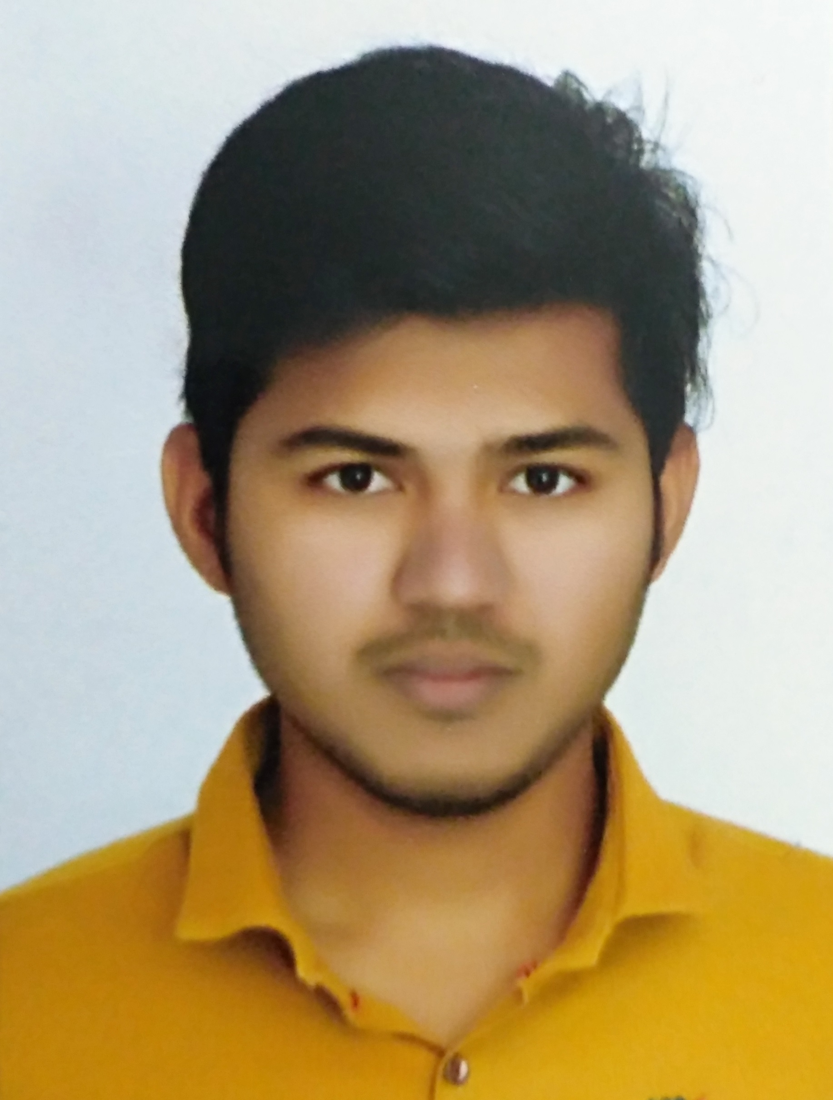
Jetpur, Dis: Rajkot,
Gujarat-360375
+91-9725087240
kevindobariya.001@gmail.com
KEVIN DOBARIYA
Objective | To start a career with an organization that provides excellent engineering environment - enables me to apply my skills to achieve objectives of organization.
ACHIEVEMENTS  &  Highlights | - Mentor of “TEAM OJASWAT” - the official Formula 3 racing team of CHARUSAT University, and making F3 car for national level event ‘Formula Bharat-2018’.  - Participated in ‘Formula Bharat-2017’ for that we made a racing car – ranked in Top 20 amongst all India.  - Co-Author of 2 Research Articles (+1 Under Review) published by Elsevier and McGraw Hill pub. Ltd.  - Selected for ONGC summer Trainee (One of the 5 Students selected from the 2nd & 3rd year of Mechanical Engineering Department, CHARUSAT)  - Organizer and Tutor of CHARUSAT Rural Education Development Program under which around 200 poor rural students of std. 1 to 12 have got an essential education and facilities at free of cost – granted by CHARUSAT University.  - Awarded by scholarship from Foundation for Excellence, India during 4 years of B.Tech program.  - Won 1st prize and honored as Auto Expert in Automobile Quiz Competition organized by Society of Automotive Engineers (SAE) Colligate Club.
Education
  course | university / board | month-year | percentage/cgpa
  B. TECH - mechanical | charusat university | may-2017 | 8.70 (UPTO 7TH SEM)
  12TH | ghseb | MARCH-2013 | 81%
  10TH | gseb | MARCH-2011 | 91%
INTERNSHIPS  &  TRAINING | - At ONGC Ltd., Mehsana (may-june,2016)  - At Captain Tractors Pvt. Ltd., Rajkot (December,2015)  - At Rainbow Powder Coat, Anand (june,2015)  - At Excel Engineers, Rajkot (june,2014)
Project works | - Making of Formula -3 Racing Car - Designed a Steering System.  - Effects of Annealing on TiN Nano-Coating prepared by Magnetron Sputtering.  - Statistical & Experimental Investigation of Tribology for Steel/Steel, Brass/Steel pair
Publications | - Kevin Dobariya, Lathia RV, Chauhan KV, “Effects of Annealing on TiN nano-coating prepared by Magnetron Sputtering”, Thin Solid Films (2017). (Under Review)  - Lathia RV, Kevin Dobariya, A,nkit Patel, Hydrogen Fuel Cells for Road Vehicles, s 141(2017):462, doi: 10.1016/j.jclepro.2016.09.150  - Lathia, Rutvik, Tarun Agrawal, Kevin Dobariya, Vishal Parmar, and Ankit Patel. 2015. "Heat Death (The Ultimate Fate of the Universe)" International Conference on Innovative Research in Engineering, Science and Management (ESM-15). New Delhi: Tata McGraw-Hill. 162-166. doi: 10.13140/RG.2.1.4158.2485.
Certificates  &  participation | - Coordinator of Workshop “Recent Trends in Advanced Nano-materials: Synthesis and Characterization” during 15th – 16th February, 2017 at CHARUSAT, Changa.  - Participate in Workshop on "Synthesis by Sputtering" during February 26, 2016 at CHARUSAT University  - Participate in Workshop on "Non Destructive Testing" during September 29, 2014 at CHARUSAT University.  - Participated in Auto Expert Quiz Competition conducted by SAE Colligate Club & secured 1st position.  - Participated in MINI ACREX Quiz Competition conducted by ISHRAE CHARUSAT.  - Participated in Ultimate Roller Coaster Event during September 5-6, 2014 in COGNIZANCE - 14 organized by CHARUSAT University.  - Participated and won in Science Fair, General Knowledge Quiz Competitions like Gujarat Science Olympiad, in that I secured 17th rank in all over Gujarat State.
Skills & Abilities | - Soft Skills: Auto Cad, MS Office, Solid Works  - Team Player (Worked with 25 members of team for 1 year)  - Ability to Work Hard  - Ability to Motivate  - Good Analytical Abilities
PERSONAL DETAILS | Date of Birth : 27th march, 1996  Gender : Male  Languages Known : English, Hindi, Gujarati  Hobbies : News Paper reading, Drawing  Contact no. : +91-9725087240  E-mail : kevindobariya.001@gmail.com  Linked In : www.linkedin.com/in/kevin-dobariya-728208a8/

