CURRICULUM VITAE
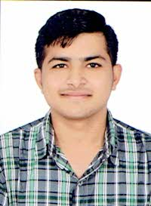

- PERSONAL DETAIL

- Name : Hardik Kumar Kantilal Kateliya
- Mobile : +91 8347914737
- E-mail : hardikkateliya.108@gmail.com
- Birth Date : 27th September 1995
- Marital status : Unmarried
- Blood group : AB+ve
- Language known : English, Hindi, Gujarati
- Hobbies : Solve puzzle, Playing cricket
- Address (Permanent ) : At-Girdevli, Ta-Kodinar, Di-Gir Somnath,(Gujarat), Pin-362220
- Address (Local) : 13, Sarveshwar Flats, 289, New IPCL road, Gorwa,Vadodara-390016

- CAREER OBJECTIVES

- To achieve Organization’s objective as well as self-set goal within a stipulated time.

- EDUCATION QUALIFICATIONS

COURSE | INSTITUTE | YEAR | CGPA/PERCENTAGE
B.E. | Production Engineering Department  Shantilal Shah Govt. Engineering College,Bhavnagar | 2016 | 7.36 CGPA
H.S.C. | Tapovan Vidya Sankul Ankolwadi (Gir) | 2012 | 68%
S.S.C | GSEB | 2010 | 77.69%

- PROJECT

Surface Roughness Modeling With Machining Parameters (Spindle Speed, Feed Rate & Depth of Cut) in CNC Turning

- Additional Information

- Aware with Manufacturing Processes
- Good engineering drawing reading capabilities.
- Having good communication skill.
- Positive attitude, Team Work, Punctual

I assure you sir, if I am given a chance to serve your esteemed organization, I will work with full sincerity, hard working and dedication and will not give you any chance for complaint.

Hardik Kateliya

