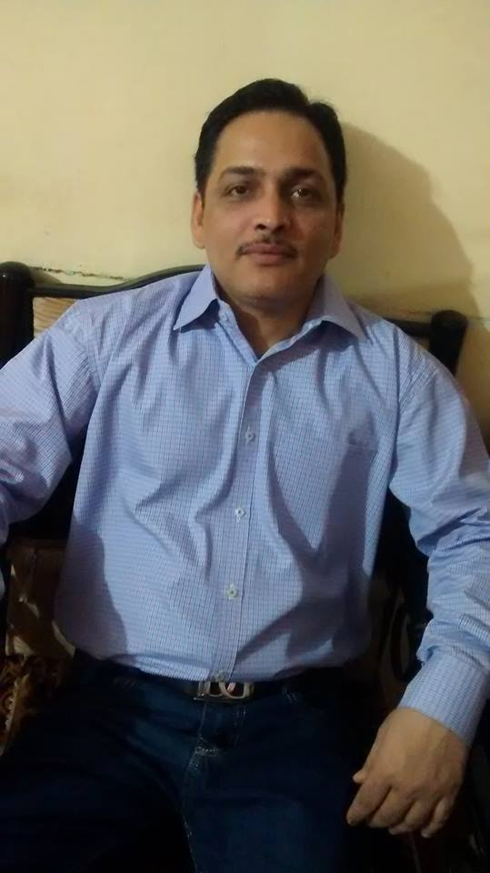

PROFESSIONAL OBJECTIVE
Strive towards achieving a challenging position in a progressive organization using the latent and acquired skills and work towards a mutually beneficial growth both for the organization and for self.

PROFESSIONAL EXPERIENCE

Role : Marketing Officer
Organisation : Sunflag Iron & Steel Co.Limited
Reporting : Dy.G.M. (Mktg.)
Location : Thane ( Maharashtra)
During : April’10 – till date

Responsibilities:

Marketing of Alloy Steel wire rod & round bar:
. Preaparation of Business forecast
. Customer visit for Business development.
. Presentation of company’s profile & complete product details along with process route.
. Understanding the detailed requirement of customers with complete technical specification.
. Resolving technical differences between customers specification & our plant capability.
. After resolving differences, submitting offer of required material.
. Negotiation & Finalization of order.
. Preparation of Customer Credit Limit in SAP.

Sales Activity:
. Sending customer code format to customer for creating customer code in our SAP system
. Preparation of Pricing document in online Pricing System.
. Preparation of Sale Order in SAP after price approval & sending rolling plan to plant.
. Despatch of material as per Schedule.
. Payment follow up with customer. Account reconciliation.
. Providing information of despatch details to customer.
. Attending customer complain , Sending sample of complained material to plant for investigation.
. Settlement of complain after discussion with DGM (MKTG) , issuing quality compensation.

Monthly Planning
Getting information of customer wise stock, ready material, material under loading , WIP material & material
pending for rolling & new material to be planned.
Preparation of monthly collection target customer wise
Reconciliation of Sale vs target , actual collection vs collection target customer wise

Marketing Intelligence Report :
Getting the complete information of material required by customer such as existing supplier, current
prices, End application of of material

Role : Sr.Markting Executive
Organisation : Goradia Special Steel Ltd
Reporting : Managing Director
Location : Khopoli
During : Feb’09 – March’2010

Responsibilities:
• Contacting Customer through Internet / Telephonic/Other Media Sources.
• Visiting for Customer development.
• Submission of Company’s profile with product details to interested Customer.
• Discussion with customer for their requirement.
• Follow up with Marketing Coordinator for offer submission & follow up for order.
• Follow up with Plant for timely process & dispatch of goods.
• Follow up for payment with customer.

Role : Sales Executive
Organisation : Damani Swift Trade Private Limited
Reporting : Director
Location : Mumbai
During : April 2005 – May’08

Responsibilities:
• Contacting Customer through Internet / Telephonic/Other Media Sources.
• Sending our Company’s profile with product details to interested Customer.
• Preparing and submitting our offer to Customer. Follow up with customer for
order.
• Arranging timely dispatch of goods to customer and sending dispatch documents as per Commercial terms & conditions finalized.
• Follow up for payment with customer.
• Making Monthly sales statement & outstanding payment statement
• Visiting customers for attending their complaint if any and various miscellaneous work as assigned by Management time to time.

Role : Purchase Officer
Organisation : Multimetals Limited
Reporting : Vice President
Location : Kota ( Rajasthan)
During : April 1997–Nov 2004

Responsibilities:
• Overall responsible for Store & Purchase Activity
• Sending Enquiry to various Suppliers. Preparing Comparative Statement after
receiving offers. Negotiating with supplier for required material.
• Taking approval from senior authority and releasing order.
• Follow up with Supplier for material and follow up with account department for releasing fund for suppliers.
• Awarding labor contract & Civil contract to contractor after negotiation of rates.
• Inspection of incoming material and preparing incoming material receipt note and sending the same to concerning department for material approval.
• Maintaining minimum level of critical items. Physical verification of store
items during financial Audit.
• Various miscellaneous work as assigned by Management time to time.

KEY RESULTING AREAS:
• Marketing,Purchase activity
• Follow up.

COMPUTER SKILLS:
• Computer-proficient performer with expertise in Word, Excel,
• Email,Internet Surfing.
. working in SAP System

EDUCATION:
• Bachelor of Science in Chemistry, NES Ratnam College, Bhandup, Affiliated to University of Mumbai in 1st class division in 1994.
. Diploma in Business Management from AIIMS Chennai

PERSONAL DETAILS:

Date of Birth : 01/07/1974
Father’s Name : Late Shrinath
Marital status : Married
Kids Details : 1. Son : Studying in Bsc final year in Microbiology from
Mumbai University
2. Daughter : studying in BCom 1st year from Mumbai
University

Mother Tongue : Hindi
Languages Known : English (to Speak, Read and Write)
Hindi (to Speak, Read and Write)
Marathi (to Speak,Read)
Interests : Traveling

Current CTC : INR :6.37 Lac p.a.
Present Location : Mumbai, India
Notice Period : 45 days

(PRAKASHCHANDRA TIWARI)

