Aum Shree Paramatmane Namh:
Dr. Chirag Patel
Dr. Raj Shah
M.D. Part – 2

Case of brain tumor ( Glioma)
In this given paper I have present the case of brain tumor of 45 years old female, the detail about case describes bellow and same haw my understanding of case also give in this paper.
Detail about case
Name- Shardaben r. Patel
chief complain
- Patient feels heaviness in head and numbness in right side, within 5 minute patient became unconscious. Patient cannot remember about that acute episode. Patient feels heaviness in head and numbness in right side.
0.D.P.
- Patient was all right before one month of acute attack of complains. Then patient gradually felt tingling sensation in leg first start on right side and slowly whole right side was affected. Then after one months of time patient got acute attack of convulsion at early morning and then after patient had hospitalized and operated for tumor and was exposed to chemotherapy. After all this she got started with complaint of prolonged weakness, drowsiness and edema.

Associated complains
-Burning in the foot in both legs.
-burning in the eye < at winter.
-weakness in the whole body .
-pain slowly migrate leg to lower part of back.
- itching with scratching on leg and forearm till part bleeds.

Patient as person
- Patient was workaholic and be accurate in daily routine work. She was housewife and his husband was primary school teacher. Before that there was no any maser illness in patient. One alder son was got job in Jamnagar and younger son selected for military training before 4 month. Patient very much worried about younger son who was in training and says “if my son Hemik coming back home then after all my complain became normal, I am so much worried about my son.
Q. But why you think like that?
Ans. – if something bed happening with Hemik what will our society think about us to send our son in national military (Army). People say like that for the money you send your son in military. So I am worried about that.
Physical general symptoms:
Thirst- Large quantity of water at long intervals.
Appetite- decreased since last 7 months.
Desire- sweets
Perspiration- profuse on whole body.
Mental generals
Patient need everything in its proper place otherwise patient got angry.
Patient must need everything clean and clear.
He is constantly worried about her younger son who is in army.
M.R.I.- Possibility of granulomatous lesion ( tuberculomus) most likely.
H.B.- 8.7%
W.B.C.- 9100 cu/mm
E.S.R- 14 /hr.
My first prescription about this case was
Rx. Phos – 30 O.D. morning and Nux. Vom. 30 Hs at night
- Phosphorus was my first priority because whole totality cover by phosphor and M.R.I. finding suggested possibility of tuberculomusgranulomatuos lesion. And Nux. Vom. For removing of side effect of allopathic drugs.
But after three days of my first prescription all complain of patient had sever aggravate. Patient became more fastidious.Aggravation of complain was the positive sign but patient’s physical generals was not improve this indication suggest the prescription was not perfect. So my second prescription was change and I had given Arsenic alb.-30 OD in Morning for 7 days.
After the Arsenic prescription gradually all the complaint of patient was improved and patient feels better.
My reportorial totality is given below with indicated group of medicine.

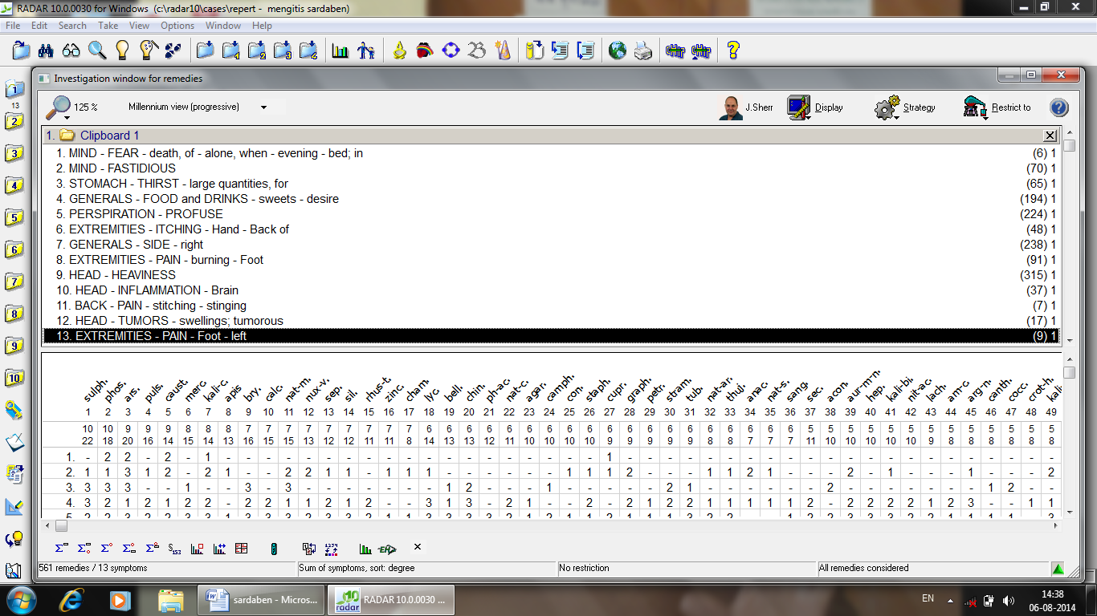

Conclusion:- Although it is important to understand the diagnosis , the phase and the pathological involvement in a disease condition for remedy selection and management of the case but more than that it is important to understand the patient as a whole, because only then can a true picture of the manifesting disease can be understood . In the words of Dr. Hahnemann there are no diseases but sick individuals. Hence, by understanding the sick person underneath the manifesting symptomology we can bring about cure in true sense.

- First MRI findings of patients after first acute attack of convulsions and before the surgery.

