AUTOIMMUNE DISEASES & HOMOEOPATHY
DR. NIDHI TIWARI

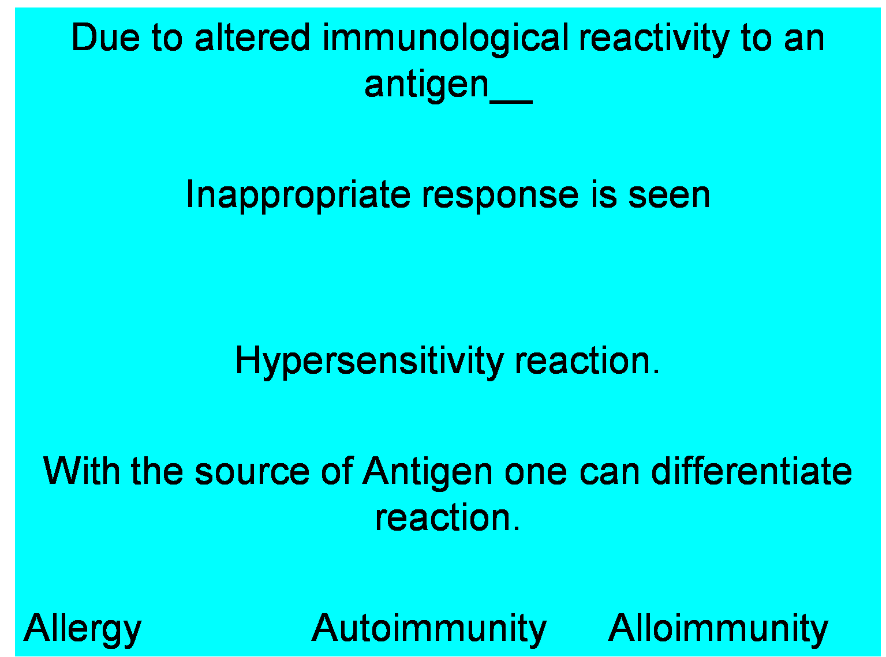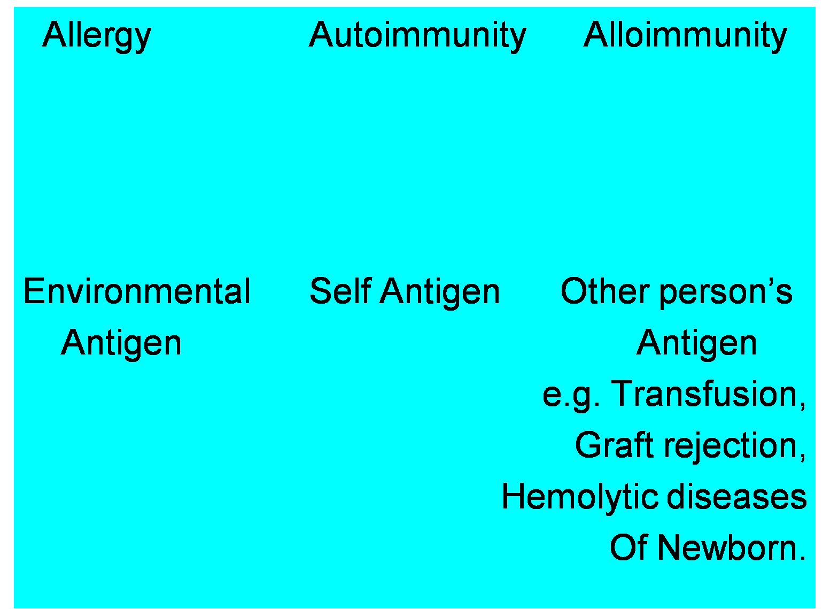
DEFINITION:
- An autoimmune disorder is a condition that occurs when the immune system mistakenly attacks and destroys healthy body tissue. There are more than 80 different types of autoimmune disorders.
- Normally the immune system's army of white blood cells helps protect the body from harmful substances, called antigens. Examples of antigens include bacteria, viruses, toxins, cancer cells, and foreign blood or tissues from another person or species.
- The immune system produces antibodies that destroy these harmful substances. But in patients with an autoimmune disorder, the immune system can't tell the difference between healthy body tissue and antigens & immune response that destroys normal body tissues.

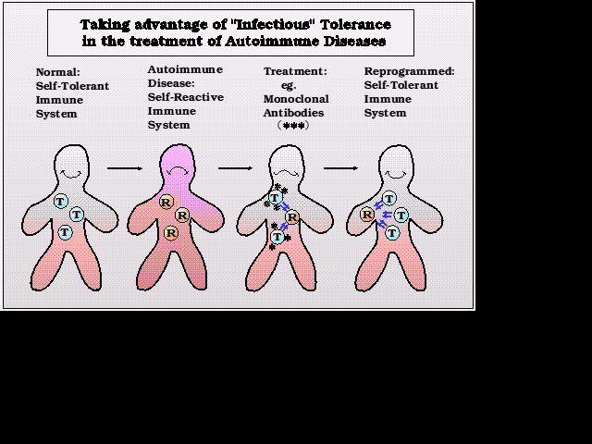
- An autoimmune disorder may result in:
- The destruction of one or more types of body tissue.
- Abnormal growth of an organ &
- Changes in organ function.
- An autoimmune disorder may affect one or more organ or tissue types. Organs and tissues commonly affected by autoimmune disorders include:
- Red blood cells
- Blood vessels
- Connective tissues
- Endocrine glands such as the thyroid or pancreas
- Muscles
- Joints
- Skin
- A person may have more than one autoimmune disorder at
the same time.
LIST OF AUTOIMMUNE DISEASES:
Name: | Autoantibody
Addison's disease | interferon omega; transglutaminase; aromatic acid carboxylase; GAD; HAI; 17 hydroxylase; 21 hydroxylase
Alopecia areata | T-cells
Autoimmune hepatitis | anti-mitochondrial antibodies;ANA; anti-smooth muscle antibodies, LKM-1; soluble liver antigen
Autoimmune pancreatitis | ANA; anti-lactoferrin antibodiesanti-carbonic anhydrase antibodies;rheumatoid factor
Berger's disease | IgA (elevated in 50% of patients), IgA (in mesangial deposits on kidney biopsy)
Bullous pemphigoid | IgG autoantibodies targeting the type XVII collagen component ofhemidesmosomes
Celiac disease | Anti-tissue transglutaminase antibodies anti-endomysial IgA, anti-gliadin IgA
Churg-Strauss syndrome | p-ANCA Eosinophilia[21]
Dermatitis herpetiformis | IgA Eosinophilia;[21] anti-epidermal transglutaminase antibodies
Dermatomyositis | histidine-tRNA anti-signal recognition peptide Anti-Mi-2Anti-Jo1.[25]
Diabetes mellitus type 1 | Glutamic acid decarboxylase antibodies (GADA), islet cell antibodies (ICA), andinsulinoma-associated autoantibodies (IA-2), anti-insulin antibodies
Erythroblastosis fetalis | ABO, Rh, Kell antibodies
Gastritis | serum antiparietal and anti-IF antibodies
Glomerulonephritis | IgA
Goodpasture's syndrome | Anti-Basement Membrane Collagen Type IV Protein
Graves' disease | thyroid autoantibodies (TSHR-Ab) that activate the TSH-receptor (TSHR)
Guillain-Barré syndrome(GBS) | Anti-ganglioside
Hashimoto's thyroiditis | antibodies against thyroid peroxidase and/or thyroglobulin
Henoch-Schonlein purpura | immunoglobulin A (IgA) andcomplement component 3 (C3)
Lupus erythematosus | Anti-nuclear antibodies[43] anti-Ro.[44] Also, they are often present in Sjögren's syndrome.[45][46]Eosinophilia[21]
Multiple sclerosis | Anti-Kir4.1 (heterogeneous)[49]
Myasthenia gravis | nicotinic acetylcholine receptorMuSK protein
Pemphigus vulgaris | Anti-Desmoglein 3eosinophilia[21]
Pernicious anaemia | anti-parietal cell antibody
Polymyositis | IFN-gamma, IL-1, TNF-alpha
Psoriasis | -----------
Rheumatoid arthritis | Rheumatoid factor (anti-IgGFc),Anti-MCV, ACPAs(Vimentin
Rheumatic fever | streptococcal M protein cross reacts with human myosin,[70]
Scleroderma | Scl-70 Anti-topoisomerase
Serum Sickness
Sjögren's syndrome | anti-Ro.[44] Also, they are often present in Sjögren's syndrome.[45][46]
Still's disease seeJuvenile Rheumatoid Arthritis | ANA
Subacute bacterial endocarditis (SBE) | essential mixed cryoglobulinemia
Wegener's granulomatosis | Anti-neutrophil cytoplasmic(cANCA)

PATHOGENESIS OF AUTOIMMUNE DISEASES
- Sex:- is a key factor in autoimmune disease, i.e. a number of autoimmune diseases are much more common in women than in men.
- Genetic background:- There is a genetic background to autoimmune diseases and a strong correlation with particular MHC haplotypes.
- T helper cells:- play a central role in autoimmunity through generation of TH1 clones which trigger tissue damage through a DTH response. Auto-reactive cytotoxic T cells develop more rarely but can emerge for example in IDDM. Thus, in certain subjects T cell tolerance can be broken.
- There is good evidence, at least in experimental models and in certain human auto-immune diseases that somatic hyper mutation is an important process leading to auto-reactive antibodies.
- Infection by certain viruses (HCMV, EBV) or bacteria results in polyclonal B cell activation. It is conceivable that this may constitute an additional mechanism for activation of self reactive B clones.
SYMPTOMS
- Symptoms of an autoimmune disease vary widely and depend on the specific disease. A group of very nonspecific symptoms often accompany autoimmune diseases, and may include:
  - Dizziness
  - Fatigue
  - General ill-feeling
  - Low-grade fever
  - Joint pain
  - Rash etc.
DIAGNOSIS:
Tests that may be done to diagnose an autoimmune disorder may include:
- Antinuclear antibody tests
- Autoantibody tests
- CBC
- C-reactive protein (CRP)
- Erythrocyte sedimentation rate (ESR)

HOMEOPATHIC APPROACH FOR AUTOIMMUNE DISEASES

Miasms & autoimmune disease:
- Symptomatology shall vary from disease to disease but pathology is same or similar in almost all autoimmune diseases.
- From pathology one can reach in to an assumption that pathology of all autoimmune disease is damage and destruction and comes under syphilitic miasm.
Treatment:
- These are obstinate and nasty diseases as they relapse due to its mechanism of self destruction. But with Homeopathic Constitutional approach of patient one can cut short the relapses of the disease and can give lasting relief to the patient. It becomes difficult to label cure to such patient but we can give relief to such an extent that it seems to be cured but relapses are common.
- It is a widely accepted that homoeopathic medications have a modifying effect on the so called PNIE axis, i.e. the Psycho Neuro Immuno Endocrine axis.
- The human body has a particular balance of functions indicated by the emotional status, immunological status and endocrine status. That is, should any of these functions be modified by any cause, such as external or environmental stress, as well as internal stress, the changes are manifested as alterations in this axis, which finally percolate down to the somatic / physical level.
- The vigour of expression at the somatic level would thus depend on the amount of change that has taken place in the individual, and the capacity of the individual to respond and recover from this state with his internal reserves. This capacity is termed in homoeopathy as the SUSCEPTIBILITY of the person.
- Thus to consider or study the immunological status of an individual from the homoeopathic standpoint, one needs to clearly assess the susceptibility of the person and all the factors that affect or modify it.
- The second important aspect of cure of immunological diseases is with regard to the choice of the remedy. It is essential that the remedy is a SIMILIMUM or "CONSTITUTIONAL" , i.e. based on both mental and physical generals of the patient. Only this remedy would obtain a continous, lasting and modifying effect on the immune system as well as the PNIE axis .
ANIMAL KINGDOME & AUTOIMMUNE DISEASE:
- As we know, "fight ends in destruction" is the theme of autoimmune disease. We restrict our prescription to Animal kingdom. Fight for survival is the theme of animal remedy. Almost all animal remedies come under syphilitic miasm except a few. So various animal group remedies can be useful as per indications.

REFERENCE:
- Harrison’s internal medicine
- Lange’s pathophysiology of diseases
- Robin’s Pathology
- The Principle & the art of cure by homoeopathy,
Dr. H. A. Robert
- www. Wikipedia/autoimmune diseases

------------------------------------------------------------------------

