RESUME 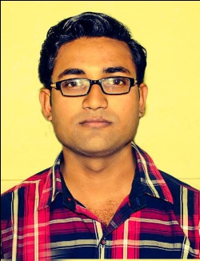
Name : Dr. Anand Bhardwaj
Reg.No.-32224 (Bihar)
Mobile No. :- 7050592956

CAREER OBJECTIVE:-
● To choose the work I am interested in which I can perform at my level best.
● To deliver my duties very sincerely and regularly in the interest of organization. .
● To grow in all means with time on my efforts.
EDUCATIONAL QUALIFICATION:-

Examination | Board/University | Passing year | Marks in% | Div
MATRICULATION | B S E B PATNA | 2007 | 61 | 1st
INTERMADIATE | B S E B PATNA | 2009 | 65 | 1st
BHMS | B R A MUZ (BU) | 2015 | 67 | 1ST
INTERSHIP | B N M H MADICAL COLLEGE AND HOSPITAL BIHAR | 2016

PERSONAL PROFILE:-

- Name: - DR. ANAND BHARDWAJ

- Father’s name: - SAROJ KUMAR SINGH

- Date of Birth: - 21-02-1992

- E-mail:- dranandbhardwaj@gmail.com

- Postal Address: - KAYSTH TOLA WD NO 29, SAHARSA BIHAR

- Gender: - Male

- Marital status: - Married

- Religion:- Hindu

- Language Known: - English ,Hindi & Local

- Nationality: - Indian

- Hobbie: - Making friendship and reading novel

COMPUTER KNOWLEDGE:-

- DIPLOMA IN COMPUTER APPLICATION

WORKING EXPERIENCE
RMO AT GAYTRI NURSING HOME (ICU/NICU) SIENCE 2016 TO PRESENT
STRENGTHS

- Maintaining excellent public relation.
- Showing keen interest in all the activities I do.
- Effective communication.
- Ability to adjust in any circumstance.

DECLARATION:-

I hereby declare that information provided by me in application is true, to best of my knowledge. I am aware that any omission, falsification, misstatement or misrepresentations above may disqualify me for employment, if I am hired, may be grounds for termination at a later date.

Date…09/04/2017… Yours faithfully,

Place…..SAHARSA
ANAND

