The Homoeopathic Medical Association of India, Ahmedabad Unit
Monthly Report June 2022
We did following activities in June month of 2022
- Yoga Day celebration for all by Ladies wing on 19th June 2022
- Launched STUDENT WING on 21 June 2022
- Visit to Ahmedabad Homoeopathic College, Bopal on 24th June 2022.
- CME of Dr. Bhaskar Bhatt on topic of FOLLOW-UP AND SECOND PRESCRIPTION on 26th June, 2022
- Felicitation of Dr. Bhaskar Bhatt sir for become awarded as BEST HOMOEOPATHIC PRACTITIONER at National Scientific Seminar, Aurangabad

Yoga Day Celebration
Yoga Day Celebration organised by HMAI Ladies wing Ahmedabad unit on 19.06.22 Sunday at Sanidhya Party Plot 6 am Conducted by Dr.Nilay Trivedi attended by 32 members .
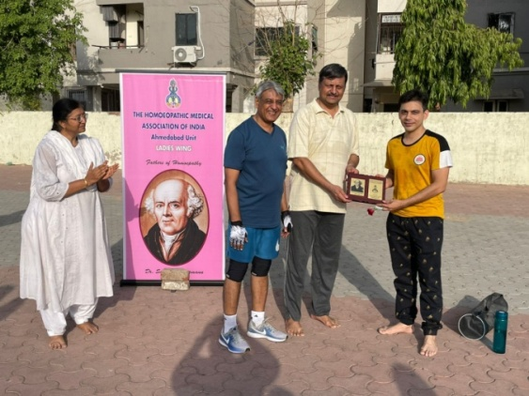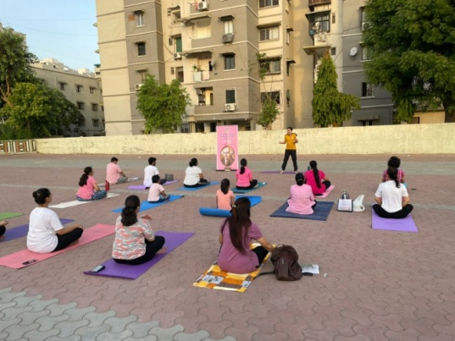
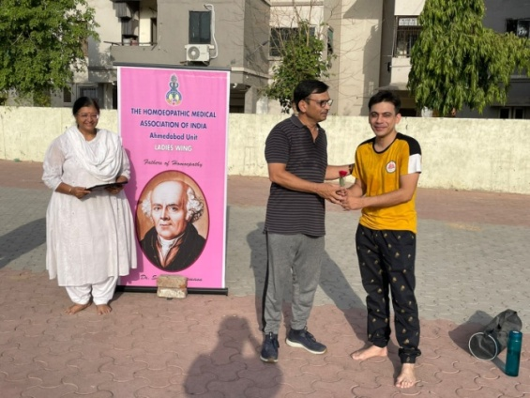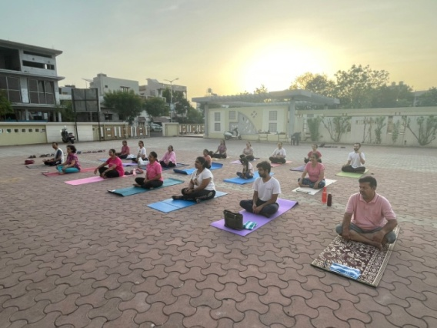

Launched STUDENT WING on 21 June 2022

We are happy to announce...
HMAI AHMEDABAD unit is launching 'STUDENT WING' today on auspicious day when the world is celebrating World Yoga Day and World Music Day.

1. It is for Under Graduate Homoeopathic student.
2. Student membership will remain for 2 years term ( at present it will remain 2022-2024 term)
3. For 2 years term fee is Rs. 300
4. Students will have to submit copy of ID proof, preferably College ID card.
5. They need to submit membership form with one passport size photo, ID proof and fees.
6. After completion of term in March 2024, student can renew the same.
7. Member student will be able to paticipate in all activities like CMEs, workshops etc. of HMAI AHMEDABAD unit.
8. Member students are abide by the rules constituted by HMAI.

Visit to Ahmedabad Homoeopathic College, Bopal

HMAI executive committee with Dr ketanbhai shah visited Ahmedabad Homoeopathic college for creating awareness of student wing on 23rd June 2022.
All the executive members reached college at 1 pm. Principal Dr. Hina Raval gave warm welcome to us. Dr. Ketan Shah led us to classes of college. We deliver our presentation in 3rd year, 4th year, to P.G. Students and to interns in different classes. All the classed were full of students. They listened us peacefully. Many of them took interest in joining HMAI Student wing. Dr. Ketan Shah, Dr. Sneha Majmundar, Dr. Mital Joshi, Dr. Mayur jasvani and Dr. Jash Mehta addressed the students. After 2 hours of hectic lectures we departed. Almost 27 student immediately joined Student wing and made our hardwork fruitful.
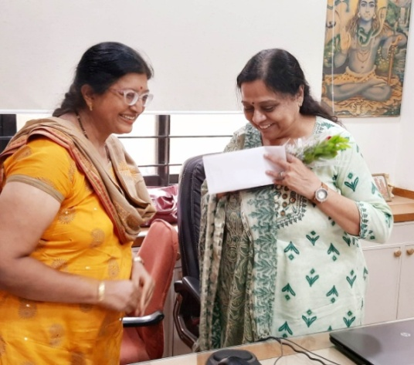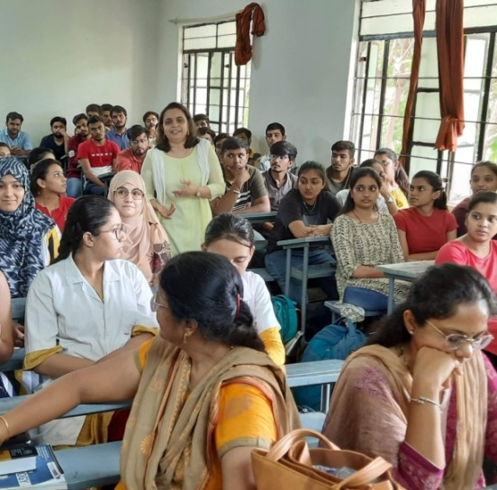

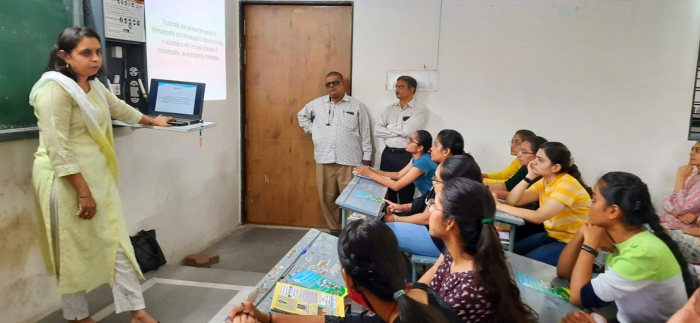

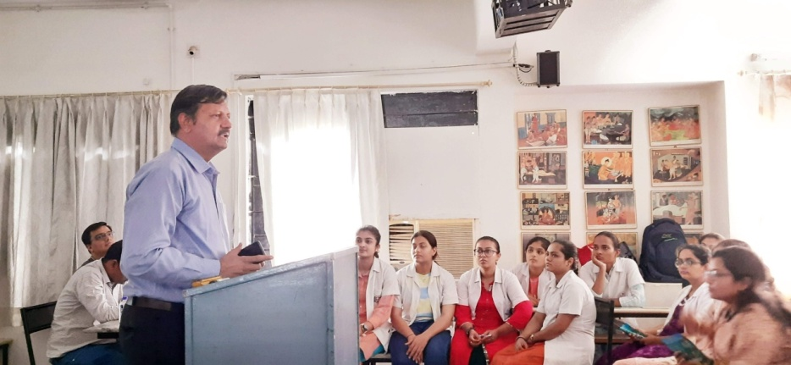

CME of Dr. Bhaskar Bhatt on topic of FOLLOW-UP AND SECOND PRESCRIPTION on 26th June, 2022.

It was a great occasion as we were started our new term with about 100 participants including newly formed STUDENT WING members. All seniour practitioners were also present.
Dr. Arohi Pandey gave introduction about Speaker Dr. Bhaskar Bhatt Sir. Dr. Bhaskar Bhatt Sir presented his lecture about the topic in detail. Main focus were questions asked by participants. He tried to answer almost all question with his vast experience. All enjoyed breakfast in recess
time. KUNAL HOMEO PHARMACY gave medicine kit to all participants. Students also gave their views on attending CME. At the end, Secretary Dr.Harshitt Trivedi say vote of thanks.
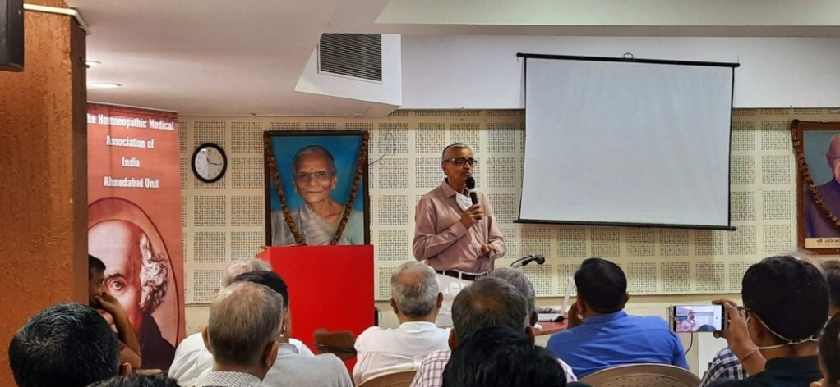

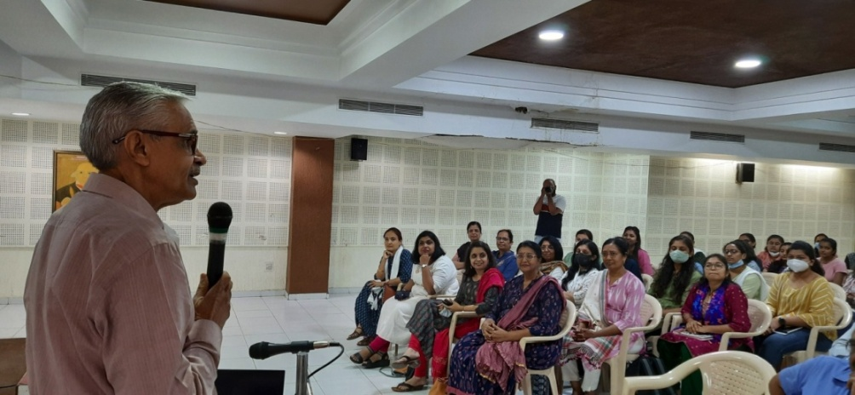

Felicitation of Dr. Bhaskar Bhatt Sir
It was a proud moment for HMAI Ahmedabad as its pioneer person Dr. Bhaskar Bhatt Sir awarded as BEST HOMOEOPATHIC PRACTITIONER at National Scientific Seminar, Aurangabad in May 2022. For the same reason we decided to felicitate him in his CME on 26th June. We presented small slide show of his journey as a Homoeopathic practitioner with help of Dr. Ketan Shah and Dr. Harshit Trivedi. Dr. Sneha Majmudar described his life jounrey in nutshell. Books were given as a token of gratitude to Sir. He also shared some of his life journey and message of struggle with participants. Dr. Tushar Doshi remembered some of his past glories with Dr.Bhaskar Bhatt. It was very emotional event all senior Doctors who witenessed his journey since inception of HMAI. He very humbly thanked All members for felicitation.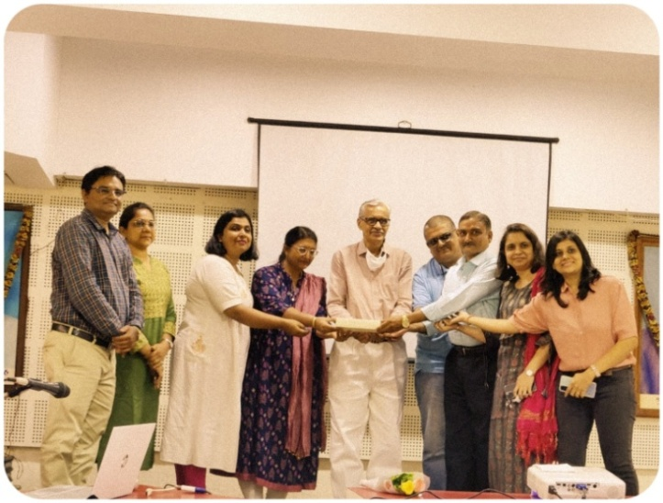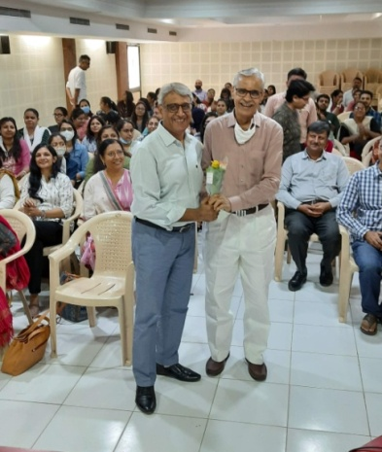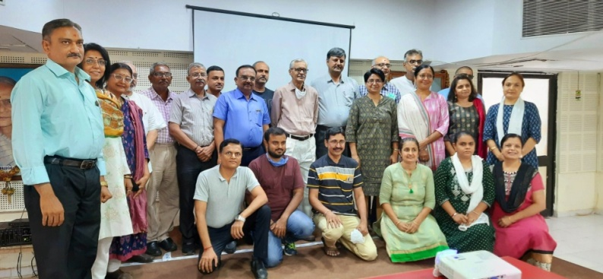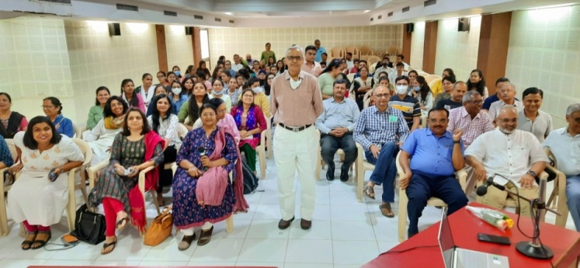

Plan for next month
- Expansion of Student wing
- Visit to other colleges
- Plan for Quiz competition
- CME on 24th July.

