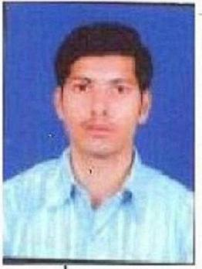

RESUME
FULL NAME : Pradip Arvindbhai Mavadiya
PERMANENT ADDRESS : Kanak Nagar Soc.,Main Road,
Opp.,Murlidhar School,
Near Shree Dugal Krupa,
Sant kabir Road, RAJKOT-360003
CONTACT DETAILS : MO. 9909605003
DATE OF BIRTH : 11th APRIL 1988
SEX : MALE
MARITAL STATUS : UNMARRIED
NATIONALITY : INDIAN
E-MAIL ADDRESS : pradip.9661arv@gmail.com
Hobby : Reading, Meat a New People

►EDUCATION QUALIFICATION :-
−−−−−−−−−−−−−−−−−−−−−−−−−−−
DISCIPLIN : T.Y.B.A, M.A., Postgraduate
UNIVERSITY : SAURASHTRA UNIVERSITY
STD | SCHOOL/UNI. | YEAR | Total Marks | Obtain Marks | PER(%)
10TH | G.S.H.S.E.B. | 2003 | 700 | 343 | 49
12TH | G.S.H.S.E.B. | 2005 | 600 | 446 | 74.33
T.Y.B.A. | SAURASHTRA UNI. | 2008 | 700 | 358 | 51
M.A. | SAURASHTRA UNI. | 2010 | 1000 | 469 | 46.9
T.Y.B.A.(P.G.) | SAURASHTRA UNI. | 2012 | 700 | 389 | 55.71
Computer Software programming | I.T.I  RAJKOT | 2009 | 400 | 261 | 65.25

► EXPERINCE :-
−−−−−−−−−−
NAME OF EMPLOYER | DESIGNATION | DURATION
BOMBAY MACHINERY SPARES NAVAGAM | MANEGER CUM COMPUTAER OPERATOR | Regular
Shree Sharda Vidhalay | TEACHING WITH MENAGEMENT | 2 Years

►JOB PROFILE:
MY CORE ACTIVITY ARE AS UNDER:
● STOCK MAINTANER.
● MAINTAIN DAY TO DAY MENDATROY & PRIVATE RECORDS
● GUJARATI TAYPING
● ALL WORK

► COMPUTER EXPOSURE :- 1) MS- OFFICE (WORLD, EXCEL,)
2) OPERATING OF MIRACLE SOFTWARE

ALL THE INFORMATION ABOVE ARE TURE AND BEST OF MY KNOWLEDGE
PLACE :- RAJKOT
Your Truthfully
MAVADIYA PRADIP A.

