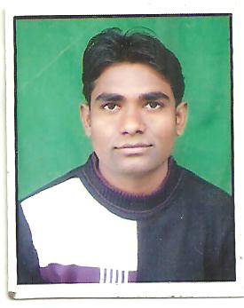  KULDEEP  Contact Information:  Contact No:  +07210548795  +09927154967  Email:  Kumar.kuldeep42@gmail.com  Permanent Address:  Vill.&Post-Salempur Gausai, Distt.-Amroha (U.P.), 244235  Personal Data:  DOB : 11-July-1987  Sex : Male  Nationality: Indian  Marital Status: Single  Languages Known:  English& Hindi  Hobbies:  - Listening to music  - Love to play cricket  - Reading Book | CURRICULUM VITAE  Objective  Seeking a passionate career opening in an organization, this nurtures talent, and provides a work environment that allows independence, inspires excellence and cheerful corporate culture.  Academic Qualification  Master of Business Administration  - VENKATESHWARA INSTITUTE OF TECHNOLOGY, Meerut ) Affiliated to M.T.U. Noida.  Specialization:  - H.R.  - Marketing  Bachelor of Computer Application.  VENKATESHWARA INSTITUTE OF COMPUTER SCIENCE & TECHNOLOGY, Meerut ) Affiliated to C.C.S.U.Meerut  - In the Session 2007 -2010  Intermediate (10+2)  - From U.P.B.Uttra Pradesh (Gyan Bharti Inter College , Gajraula, J.P.Nagar)  - Done in Science Stream.  - In the year 2007  High School:  - From U.P.B.Uttra Pradesh (Gyan Bharti Inter College , Gajraula, J.P.Nagar )  - In the Year 2004
Computer Proficiency
- MS Office
- Excel
- Networking

Working Experience:

- 3 Months in TATA NANO Meerut.
- 6 Month Working in Big Bazar Melange Mall, Meerut.
- 2 years Working in A2Z Infra Services LTD,Mumbai

Competencies & Skills
- Easily adjustable in every situation.
- Love to work and lead the team.
- Strong will power

Declaration
I confirm that the information provided by me is true to the best of my knowledge and belief.

Place : _______________________
Date : Signature

