CURRICULUM VITAE

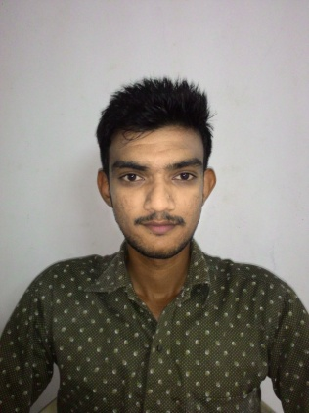
Name: Rathod Hardik Babubhai
Contact Information:
3rd floor Flat 302 Panchvati apt,
Magannagar 2, near Dhanmora,
Katargam, Surat-395004.
Gujarat (India).
Mobile: 8460569357, 9978846188
E-Mail Id: rathodharry888@gmail.com

Career Objective:-
To work for the Organization and to enhance my Communication skills I found during my training and project work .To secure a promising position in the organization that offers a good opportunity for growth and to meet the challenges of tomorrow through continuous learning and hard work.

Educational Background:-
- B.B.A. from Shree Uttar Gujarat BBA College, Surat.
(Affiliated to VNSGU)

Examination | School/College | Obtained  Result | Passing  Year
10th | SV vidhalaya | 73.85% | 2009
12th | Balasharam Vidhyalaya | 70.53% | 2011
B.B.A.1 sem | Shree Uttar Gujarat BBA College | 51.37% | 2012
B.B.A.2 sem | Shree Uttar Gujarat BBA College | 50.25% | 2012
B.B.A.3 sem | Shree Uttar Gujarat BBA College | 53.75% | 2013
B.B.A.4 sem | Shree Uttar Gujarat BBA College | 52.38% | 2013
B.B.A.5 sem | Shree Uttar Gujarat BBA College | 53.88% | 2014
B.B.A.6 sem | Shree Uttar Gujarat BBA College | 52.64% | 2014

      - TRAINING OF PROJECT:-
- Summer Training Project:
General report on Diamond Industry.
- Area of Survey :
For Functional area like Finance Management, Marketing Management, Production Management, H.R. Management.
- Grand project report:
Grand project report on Patel Motors.
- Area of Survey:
Service Quality of Patel Motors.

- PERSONAL DETAILS:-

- Name : RATHOD HARDIK BABUBHAI
- Date of Birth : 14TH SEPTEMBER 1993
- Religion : Hindu
- Sex : Male
- Marital status : Unmarried
- Languages : English, Hindi, Gujarati
- Hobbies : play cricket, reading books,
- Height : 66 cm (5.6 fit)
- Weight : 52kg

- DECLARATION:-

I hereby declare that the above mention all information is correct up to my knowledge and I bear the responsibility for the correctness of the above mentioned particulars.

Place: Surat.

YOUR FAITHFULLY, Rathod Hardik B.

